**Chapter 6**

**MR APPLICATIONS**

### **Abbreviations**

|  |  |  |  |
| --- | --- | --- | --- |
| ADC: Apparent Diffusion Coefficient | | |  |
| AIF: Arterial Input Function | |  |  |
| CBF :Cerebral Blood Flow | |  |  |
| CBV: Cerebral blood volume | |  |  |
| CTC: Concentration–Time Curves | |  |  |
| DCE: Dynamic contrast enhancement | | |  |
| DSC: Dynamic Susceptibility Contrast | | |  |
| DTI: Diffusion Tensor Imaging | |  |  |
| DWI: Diffusion weighted imaging | | |  |
| FA: Fractional Anisotropy | |  |  |
| GUI: Graphical User Interface | |  |  |
| IVIM: Intravoxel Incoherent Motion | | |  |
| LPCA: Local principal component analysis | | | |
| MR: Magnetic Resonance | |  |  |
| MTT: Mean Transit Time | |  |  |
| NRMSE: Normalized Root Mean Square Error | | | |
| PK: Pharmacokinetic | |  |  |
| PLS: Partial Least Squares | |  |  |
| PM: Perona-MaliK filter | |  |  |
| QIBA: Quantitative Imaging Biomarkers Alliance | | | |
| QIN: Quantitative Imaging Network | | |  |
| ROI: Region of Interest | |  |  |
| SD: Standard Deviation | |  |  |
| SE: Spin Echo |  |  |  |
| SLR: Shinnar-Le Roux | |  |  |
| SNR: signal-to-noise ratio | |  |  |
| TE: Echo time |  |  |  |
| TM: Tofts Model |  |  |  |
| TM-FD: Tofts Model in Frequency Domain | | |  |
| TM-TD: Tofts Model in Time Domain | | |  |
| TR: Repetition time  **PART-II** |  |  |  |

**6.1 Introduction**

MR applications aids in morphological evaluations of various parts of the human body and enhances the diagnosis and prognosis of neuro, cardiovascular, breast, musculoskeletal etc. related diseases. MR application includes enormous collection of techniques to provide better visualization for clinical diagnosis.

Diffusion-weighted (DW) magnetic resonance (MR) imaging provides potentially unique information on the viability of brain tissue. It provides image contrast that is dependent on the molecular motion of water, which may be substantially altered by disease [1].

Dynamic contrast enhancement magnetic resonance imaging (DCE-MRI) is a well-established method for non-invasive detection and therapeutic monitoring of pathologies through administration of intravenous contrast agent. Quantification of pharmacokinetic (PK) maps can be achieved through application of compartmental models relevant to the pathophysiology of the tissue under interrogation [2].

MRI is predominantly sensitive to subject motion due to longer imaging time of most MR sequences to collect sufficient data to form an image. The effect of motion results in ghosting, blurring, geometric distortion or decreased signal-to-noise ratio (SNR) of MR images. For better diagnosis, it is required to identify and separate such artefacts from the structure of interest and the obstruction or mimicking of pathologies [3].

### **6.2 Diffusion weighted imaging (DWI) applications**

This section of the report gives details about Apparent Diffusion Coefficient (ADC) and Fractional Anisotropy (FA) map computation using Diffusion Tensor Imaging (DTI), Intravoxel Incoherent Motion (IVIM) imaging of human brain can be used to differentiate between high grade and low grade gliomas, Denoising of DWI using Persona-Malik (PM) filter and Local Principal Component Analysis (LPCA) methods and Tractography.

**6.2.1 ADC map computation**

DW requires minimum of two *b*-values to compute Apparent Diffusion Coefficient (ADC) the scan time increases with increase in number of b values. Diffusion MRI, diffusion is fully described using a single (scalar) parameter, the diffusion coefficient, D. The effect of diffusion on the MRI signal is an attenuation, S0, which depends on D (diffusion coefficient) and on the b factor(area covering the diffusion gradient) which characterizes the gradient pulses (timing, amplitude, shape) used in the MRI sequence [2] is given by:.

${S=S}_{0}*{(e}^{(-\frac{b}{D})})$ (1)

ADC map is generated by computing the above equation (1) finding D 7 different *b* values.

DW data was obtained on a 1.5T Siemens scanner, these were the following parameters Repetition time (TR) = 3000 ms; TE (Echo time) =114 ms; *b*-values = 0, 200,400,600,800, 1000, 2000 s/mm2; number of slices =1; slice thickness=8;

Figure 6.2 shows the Diffusion weighted images with corresponding b values obtained from the scanner. It shows that Signal Intensity (SI) intensity decreases with increasing b value. 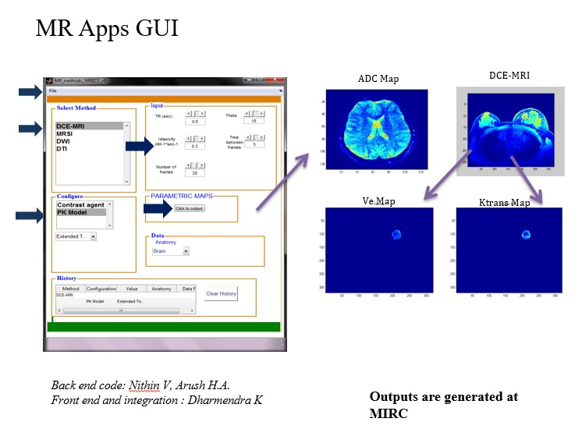

Figure 6.1: MR Apps GUI

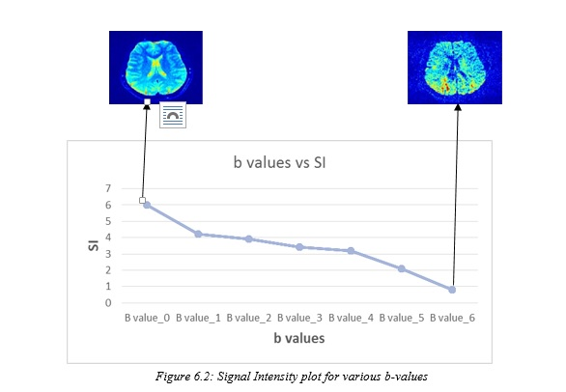

Figure 6.3 shows ADC map image obtained by fitting equation 1, as described.

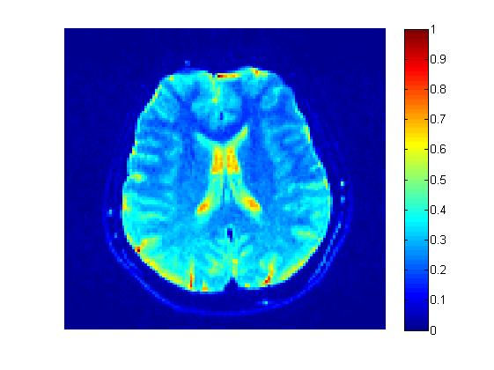

Figure 3.3: ADC map

**6.2.2 FA map computation**

Diffusion tensor imaging is a promising method for characterizing microstructural changes or differences with neuropathology and treatment. The diffusion tensor is used to characterize the magnitude, anisotropy and orientation of the diffusion tensor[4].

A minimum of six non-collinear diffusion encoding directions are required to measure the full diffusion tensor and is given by:

$D=\begin{matrix}D_{xx} & D_{xy} & D_{xz} \\ D_{xx} & D_{yy} & D_{yz} \\ D_{xz} & D_{yz} & D_{zz}\end{matrix}$ (2)

Y matrix is given by:

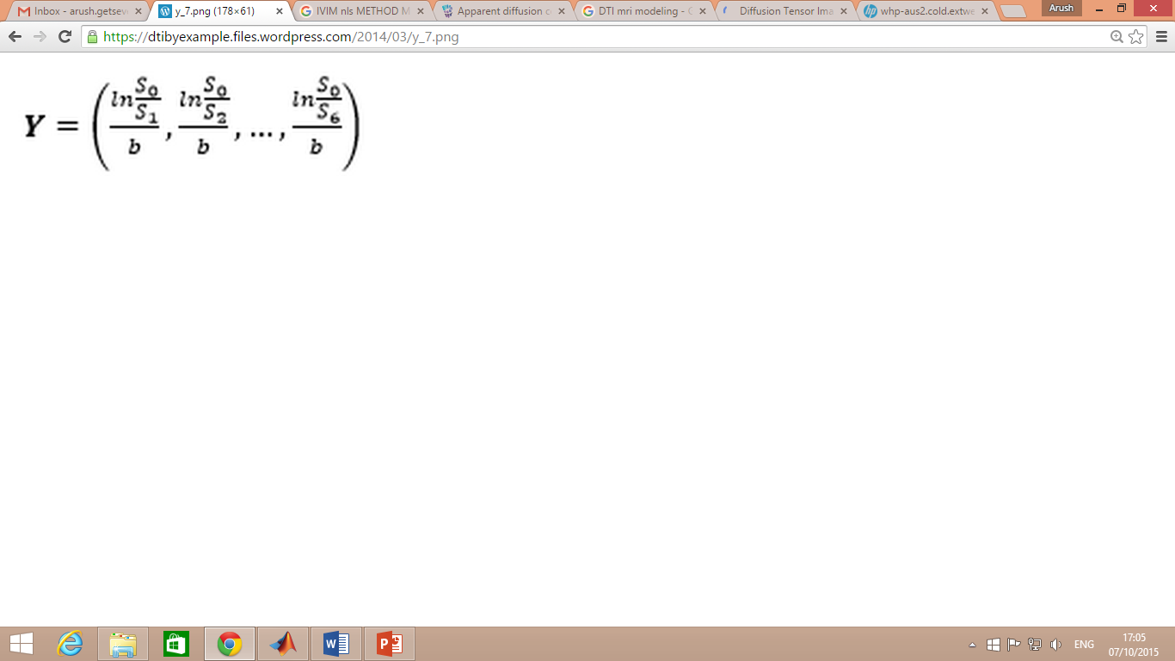

(3)

Where $S_{0}$ is the signal intensity of the non-diffusion weighted image. $S_{1}$ to $S_{6}$ are the signal intensites of the images of the same corresponding b values with different directions.

With a six-element row matrix H containing a large M x 6 matrix, where M is the number of gradient directions, here gradient directions =6 and is given by:

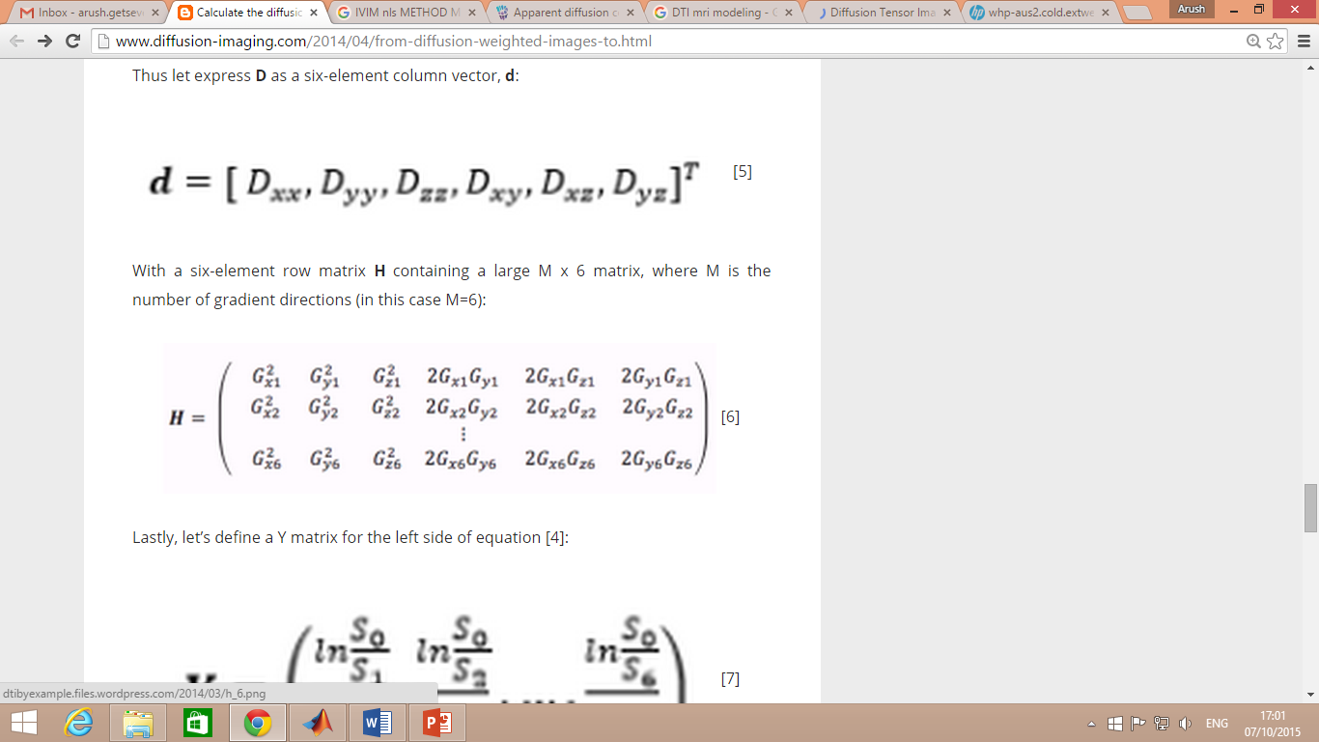

(4)

Using the above equation, we can compute the tensors using :

(5)

$Y=HD$

The obtained tensors are $D_{xx}$, $D_{xy}$, $D_{xz}$, $D_{yz}$, $D_{yy}$, $D_{zz}$ are used to compute parametric maps like Mean diffusivity(MD) , Trace and Fractional Anisotropy.FA is computed using the below equation (6):

(6)

$$FA=√\frac{3[{\left(D_{xx}-D_{av}\right)}^{2}+{\left(D_{yy}-D_{av}\right)}^{2}+{\left(D_{zz}-D_{av}\right)}^{2}+2\left(D_{xy}^{2}+D_{xz}^{2}+D_{yz}^{2}\right)]}{2[D_{xx}^{2}+D_{yy}^{2}+D_{zz}^{2}+{2(D}_{xy}^{2}+D_{xz}^{2}+D_{yz}^{2})]}$$

Apparent Diffusion Coefficient (ADC), Mean diffusivity and Fractional Anisotropy (FA) maps were computed using DTI parameters in matlab and compared with scanner results are shown in figure 6.4.

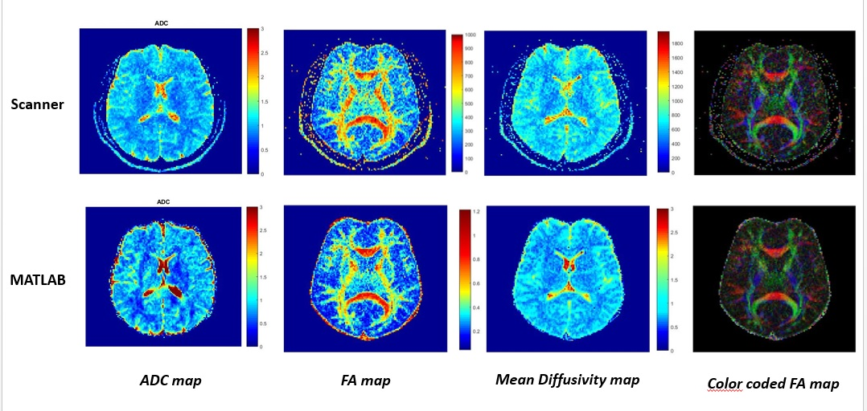

*Figure 6.4: Comparative results for DTI*

Computation of Apparent Diffusion Coefficient (ADC) and Fractional Anisotropy (FA) maps in Diffusion MRI (DMRI) using diffusion-weighted imaging is time consuming and sensitive to noise levels. Fast and robust dictionary based approach using Partial Least Squares (PLS) regression modelling [5] can provide better visualization and denoise on ADC and FA maps**.**

Difference maps of Scanner and PLS generated ADC, FA are shown in figure 6.5 illustrating relatively lesser difference between PLS and scanner results. Correlation of all pixels for PLS results and scanner computed ADC, FA maps can be seen in figure 6.6 (a) and (b).Computation time for PLS results are less compared to scanner maps and also show high SNR.

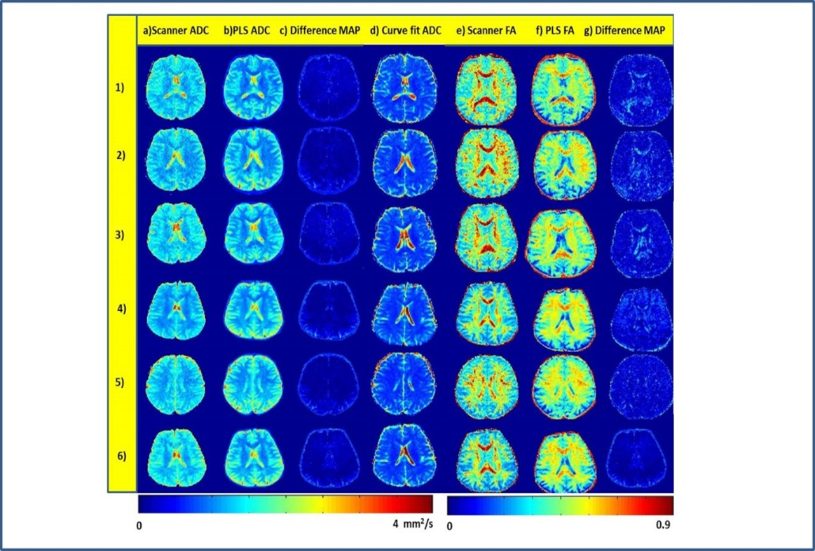

*Figure 6.5: Comparison of Scanner and PLS derived ADC, FA maps: a)&e) ADC and FA map from scanner ; b)&f)maps generated from PLS ;c)&g) difference maps of the same ; d) ADC map generated using curve fitting tool*

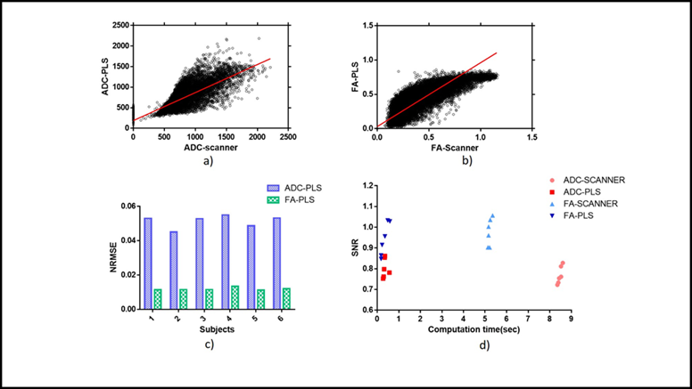

Figure 6.6: a) &b) Correlation plots of ADC and FA maps. c) depicts NRMSE plot for ADC and FA maps and d) depicts computation time vs SNR

**6.2.3 FA map filtering using Perona-Malik(PM) filter**

DTI is prone to numerous artifacts from different sources. These artifacts and low signal-to noise ratio (SNR), limit the correctness and reliability of DTI parametric maps. The basic Perona-Malik(PM) filter[6] was used to reduce the noise level and obtain better FA maps.PM filter is a technique aiming at reducing noise by preserving lines or other details that are important for the interpretation of the image. But application of PM filter works well for two b- values and produces unsatisfactory results for more b-values. Figure 6.7 shows filtered FA maps.

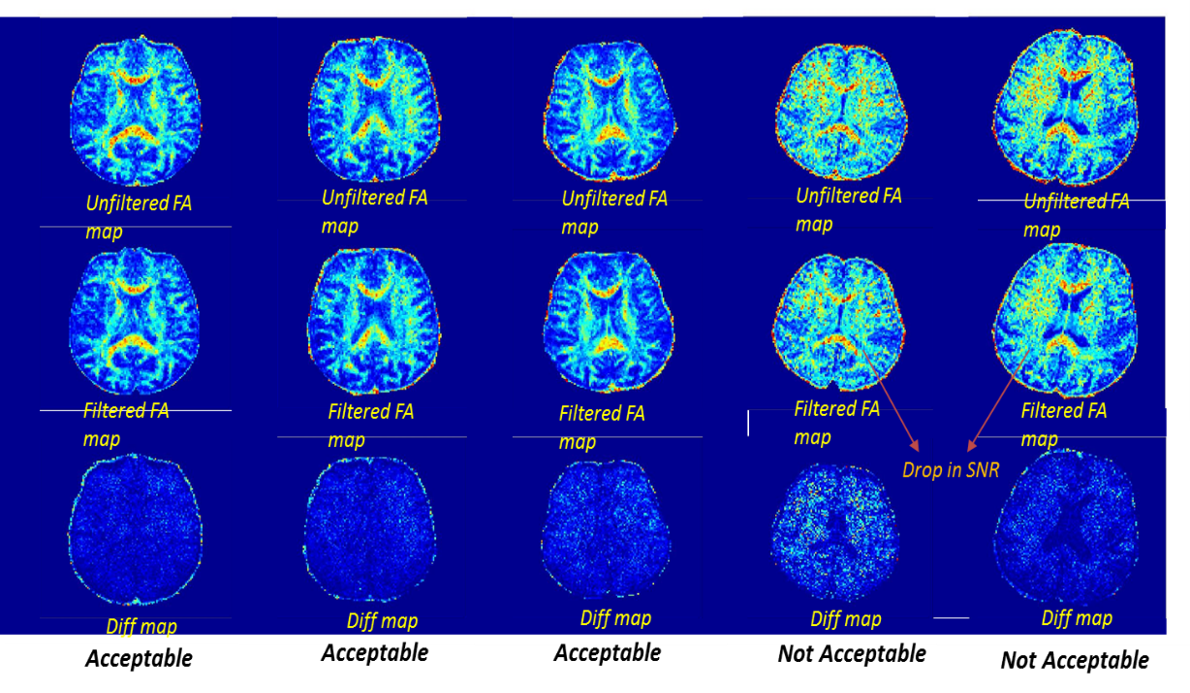

*Figure 6.7: FA maps filtered using PM filter*

Due to extremely fast echo planar acquisition, DWI suffer with poor SNR. Local principal component analysis [7] method is used to denoise diffusion weighted images for removing biased nature of Rician noise and hence producing better diffusion parameters. The LPCA filter reduces random noise in multicomponent DWI by locally shrinking less significant Principal Components using a 3-D patch around the voxel of interest based on overcomplete approach. Preliminary results are obtained using LPCA method and are shown in figure 6.8.

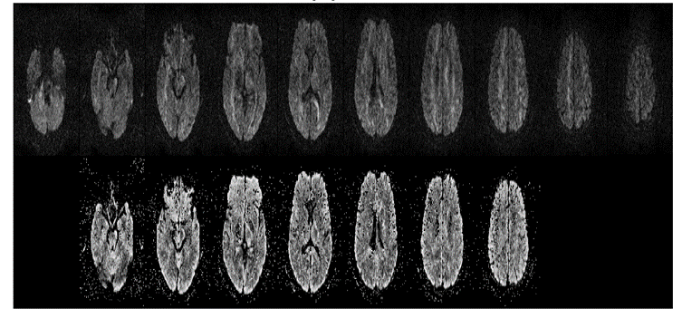

*Figure 6.8: LPCA Denoising for DWI; top row shows input images and bottom row shows denoised images*

**6.2.4 Intra -voxel Incoherent Motion (IVIM)**

Gliomas are the primary neoplasms of the brain, varying from low grade to high grade according to World Health Organization classification. The differentiation between low-grade gliomas and high-grade gliomas is critical, since the prognosis and thus the therapeutic strategy could differ substantially depending on the grade. The combination of dynamic susceptibility contrast (DSC), PW imaging and DW imaging could significantly improve the diagnostic performance [8].

Intravoxel Incoherent Motion (IVIM) imaging of human brain can be used to differentiate between high grade and low grade gliomas. The IVIM perfusion fraction f for different tumors in correlation with CBV(Cerebral blood volume) showed high intensity values at same regions. Experiment was carried for 8 cases with 80% showing the potential in IVIM on brain tumor applications because IVIM is able to generate CBF (Cerebral blood flow), CBV and ADC (Apparent Diffusion Coefficient) without contrast. IVIM parameters (f, d, D, fD*) parameters were compared to CBV maps obtained through DSC-MRI to evaluate the role of non-contrast agent based perfusion imaging are shown in figure 6.9.

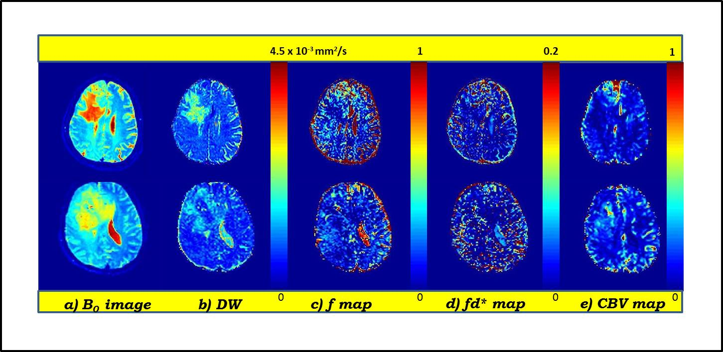

*Figure 6.9: IVIM parametric maps for patient 3 and 2*

Correlation of IVIM derived f map and cbv are shown for patient 1, 2, 3 and 4 in figure 6.10(b). In the region of interest of the maximum IVIM perfusion fraction f was significantly higher in patient 3 (r=0.3014) and patient 1 (r=0.38) with f value (0.16+0.04); CBV (0.22+0.04) and f (0.32+0.07); CBV (0.4 +0.16) respectively. f correlated comparatively less with CBV for patient 2 (r=0.031) and 4(r=0.066) with f (0.122 + 0.01) ; CBV (0.207 +0.04) and f (0.109+0.08); cbv (0.3+0.04) respectively. High grade glioma (patient 3) showed lower D (0.97+ 0.047) and higher f (0.16+0.042) than in low grade glioma (patient 6) having higher D (1.46+0.112) and lower f (0.11+0.055). D maps were lower in high grade compared to low grade gliomas**.**

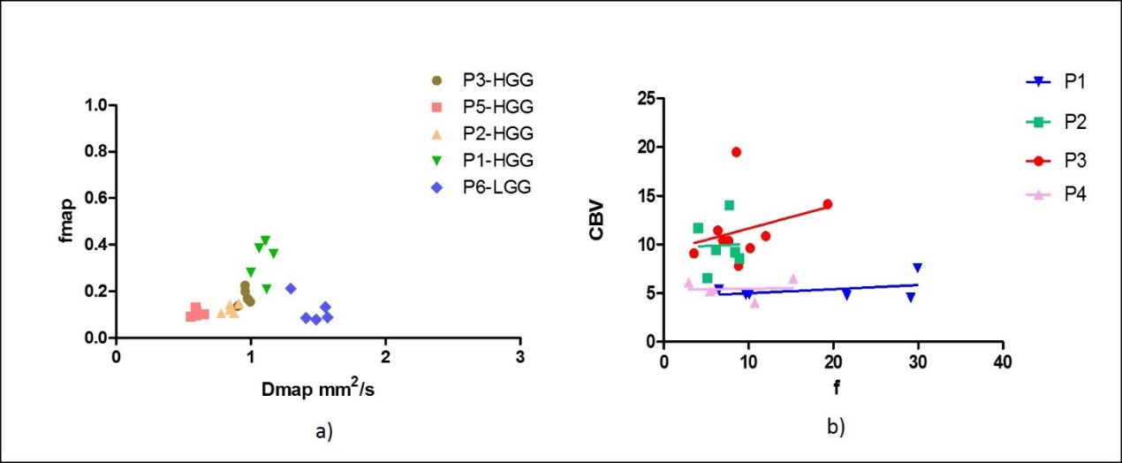

Figure 6.10: a) Shows plot of D and f obtained from IVIM. b) Shows correlation of CBV and f for 4 patients

**6.2.5 Tractography**

Tractography is a [3D modeling](https://en.wikipedia.org/wiki/3D_modeling) technique used to visually represent [neural tracts](https://en.wikipedia.org/wiki/Neural_tract) using DTI parameters. Fiber tracts calculated are visualized using colour codes[9]. Red indicates directions in the X axis: right to left or left to right; Green indicates directions in the Y axis: posterior to anterior or from anterior to posterior; Blue indicates directions in the Z axis: inferior-to-superior direction or vice versa.

Fiber tracts were parameterised as a curve using  Frenet–Serret formulas in equation(7): $\frac{ dr(s)}{ds}=T(s)$ (7)

where {\displaystyle {\mathbf {T} }(s)}T(s) is the tangent vector of the curve. The reconstructed diffusion tensor D{\displaystyle D} can be treated as a matrix, and we can easily compute its eigenvalues {\displaystyle \lambda _{1},\lambda _{2},\lambda _{3}} and eigenvectors {\displaystyle {\mathbf {u} }_{1},{\mathbf {u} }_{2},{\mathbf {u} }_{3}}e1, e2,e3. By equating the eigenvector corresponding to the largest eigenvalue with the direction of the curve using equation (8): (8)

{\displaystyle {\frac {d{\mathbf {r} }(s)}{ds}}={\mathbf {u} }_{1}({\mathbf {r} }(s))}we can solve for {\displaystyle {\mathbf {r} }(s)}r(s) given the data for {\displaystyle {\mathbf {u} }_{1}(s)}e1. This can be done using Runge-Kutta, and by interpolating the principal eigenvectors[10].Preliminary results of tractography shown in figure 6.11 is obtained using steps given flowchart[11] shown in figure 6.12

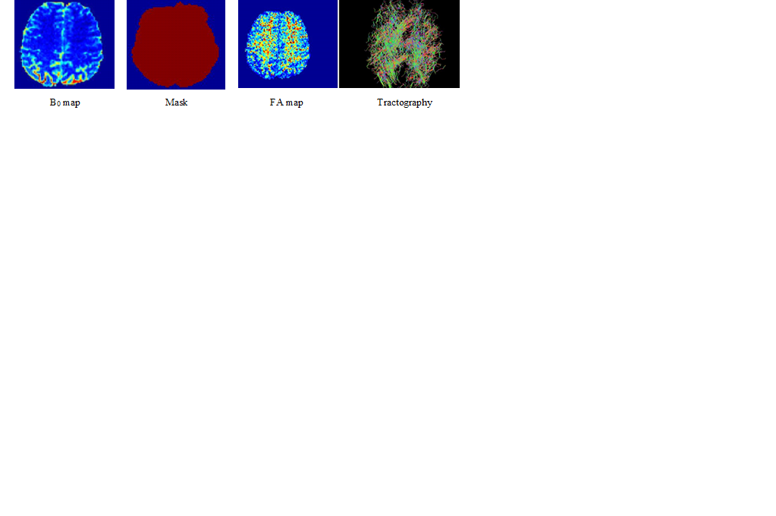

*Figure 6.11: Tractography results*

Computation of b-matrix using b-values and gradients will be the first step. Omit pixel clusters smaller than the threshhold clustersie during masking.Estimate diffusion tensor values using simple weighted approach.Eigen value decomposition is done to compute principal diffusion directions and FA map was generated.Fiber tracking was done by selecting a seed point along single direction , increment until the end ans store it. Second fiber seed was reset and steps are repeated for all the principle directions. If a single fiber segment bigger than length threshold, stopping fiber tracking.Finally fiber tracts were visualized using color code.

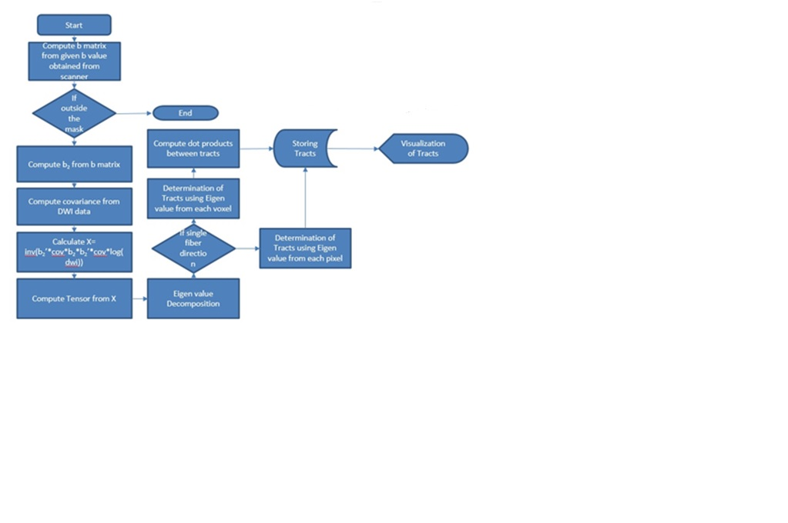

Figure 6.12: Flowchart for Tractography

**6.3 Dynamic contrast-enhanced magnetic resonance imaging (DCE-MRI)**

Dynamic contrast-enhanced magnetic resonance imaging (DCE-MRI) is a non-invasive quantitative method of investigating microvascular structure and function by tracking the pharmacokinetics of injected low-molecular weight contrast agents (CA) as they pass through the tumor vasculature [12].This technique involves serial acquisition of MR images of a tissue of interest; before, during and after the injection of CA [13]. The ions of the CA which are paramagnetic in nature interact with nearby hydrogen nuclei to shorten T1-relaxation times in local tissue water. This causes an increase in signal intensity on T1-weighted images to a variable extent within each voxel [12].

In DCE-MRI, the initial images localize the tumor and provide anatomical information. Next, sequences that allow calculation of baseline tissue T1-values before contrast agent administration are acquired to enable subsequent analysis. Finally, dynamic data are acquired every few seconds in T1-weighted images over a period of around 5–10 minutes [12].

Many techniques have been applied for the analysis of signal enhancement curves observed in DCE-MRI. The curves can be analyzed by simple visual inspection or complex quantification using pharmacokinetics models [14]. Pharmacokinetic (PK) models can be applied to CA concentration data which enables estimates of physiological characteristics such as flow and capillary endothelial permeability. The goal of PK analysis is to provide a framework wherein the kinetics of the CA within the tissue of interest can be described quantitatively and compared across data sets from one or more patients and/or MR systems.

**6.3.1 Determination of Pharmacokinetic maps using Tofts model in Time Domain**

Data used for the study was downloaded from QIN. DCE-MRI data used in this study was acquired using a Siemens 3T TIM Trio system. Breast DCE images were obtained using 3D gradient echo-based TWIST (Time-resolved angiography WIth Stochastic Trajectories) sequence. Acquisition parameters included TR/TE=6.2 ms/2.9 ms, temporal resolution= 18~20s, flip angle= 10o, FOV=30-34 cm, matrix size of 320x320, slice thickness=1.4mm. The number of frames in each breast data set ranged from 28-32 slices while the CA used was Gd (HP-DO3A) [ProHance] IV injection (0.1 mmol/kg at 2 mL/s).

The Tofts model in time (TM-TD) was applied on six breast DCE-MRI data sets from the quantitative imaging network (QIN) [15]. Population based AIF for each dataset as well as pre-contrast R10 for each ROI was provided by Oregon Health & Science University (OHSU), which was utilised to determine the kinetic parameters. The mean ± SD of the PK parameters for the chosen ROI were computed for both approaches.

TM-TD was implemented in Matlab, Mathworks Inc., Boston, MA and the configuration of the computer employed to carry out evaluation of computational time and robustness was Intel core i5, 2.60 GHz, 4GB RAM on a windows desktop PC. The values of *Ktrans* and *ve* were displayed in the form of images, as the radiologists are accustomed to interpret *ve* as compared to *Kep*, although the Tofts model returns the values of *Kep*.

Figure 6.13 shows the pharmacokinetic maps obtained from TM-TD by curve fitting the concentration time curves. It can be seen that yellow colour outline in the First row of the Fig. 8 shows the Region of Interest (ROI) selected in tumor region. Second row depicts the Ktrans map obtained for seven different datasets using TM-TD and third row depicts the Ve map obtained from TM-TD

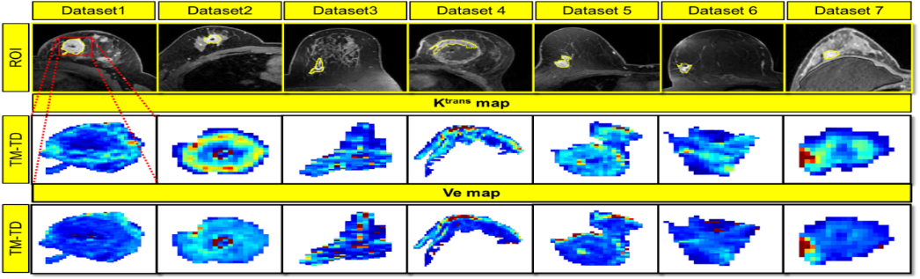

*Figure 6.13: Pharmacokinetic maps obtained from Tofts model in time domain*

Figure 6.14(a) shows Pharmacokinetics maps of randomly generated values of size 50 x 50 along with differences of three approaches with respect to the GT.

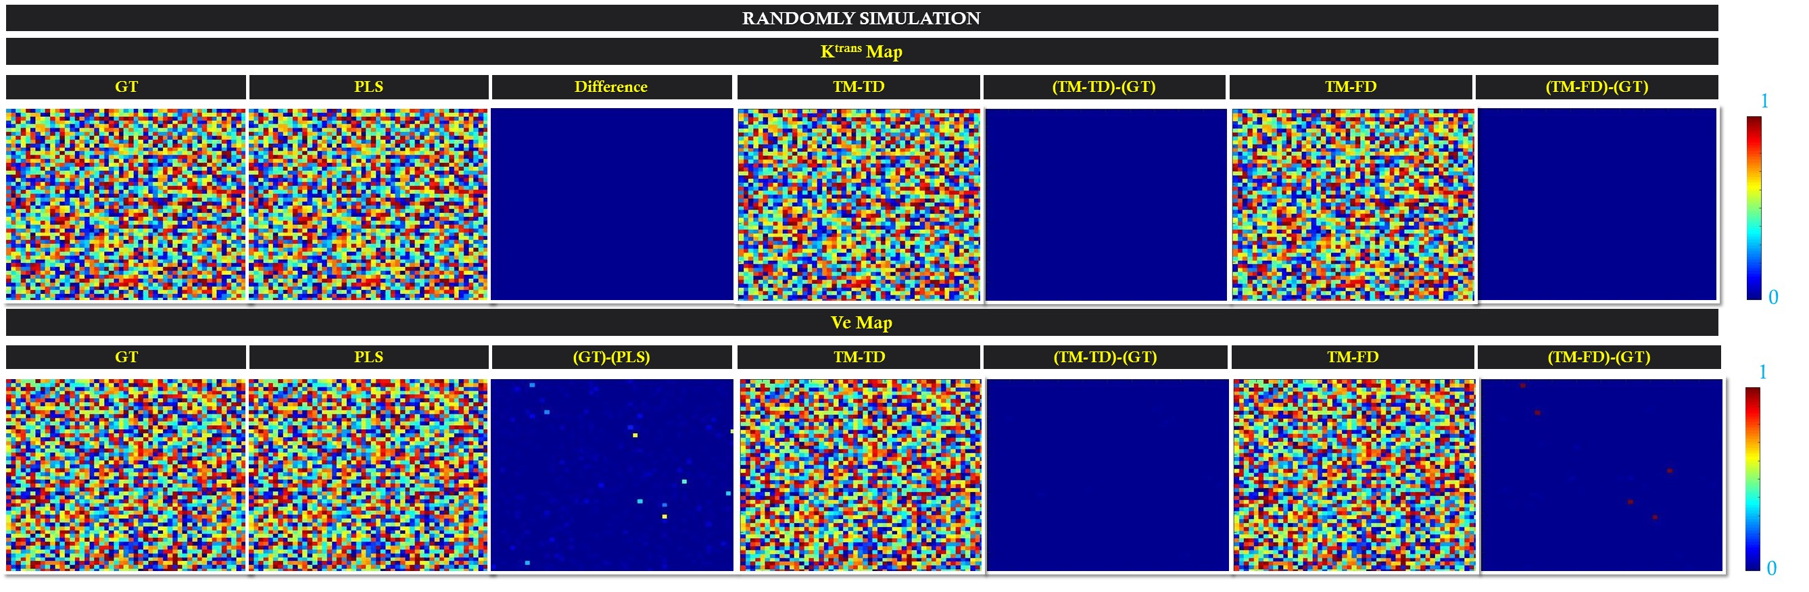

*Figure 6.14(a): Pharmacokinetic maps for In silico simulation*

Figure 6.14(b) shows representative of QIBA [7] generated values of size 180 x 60 along with differences of three approaches with respect to the GT.

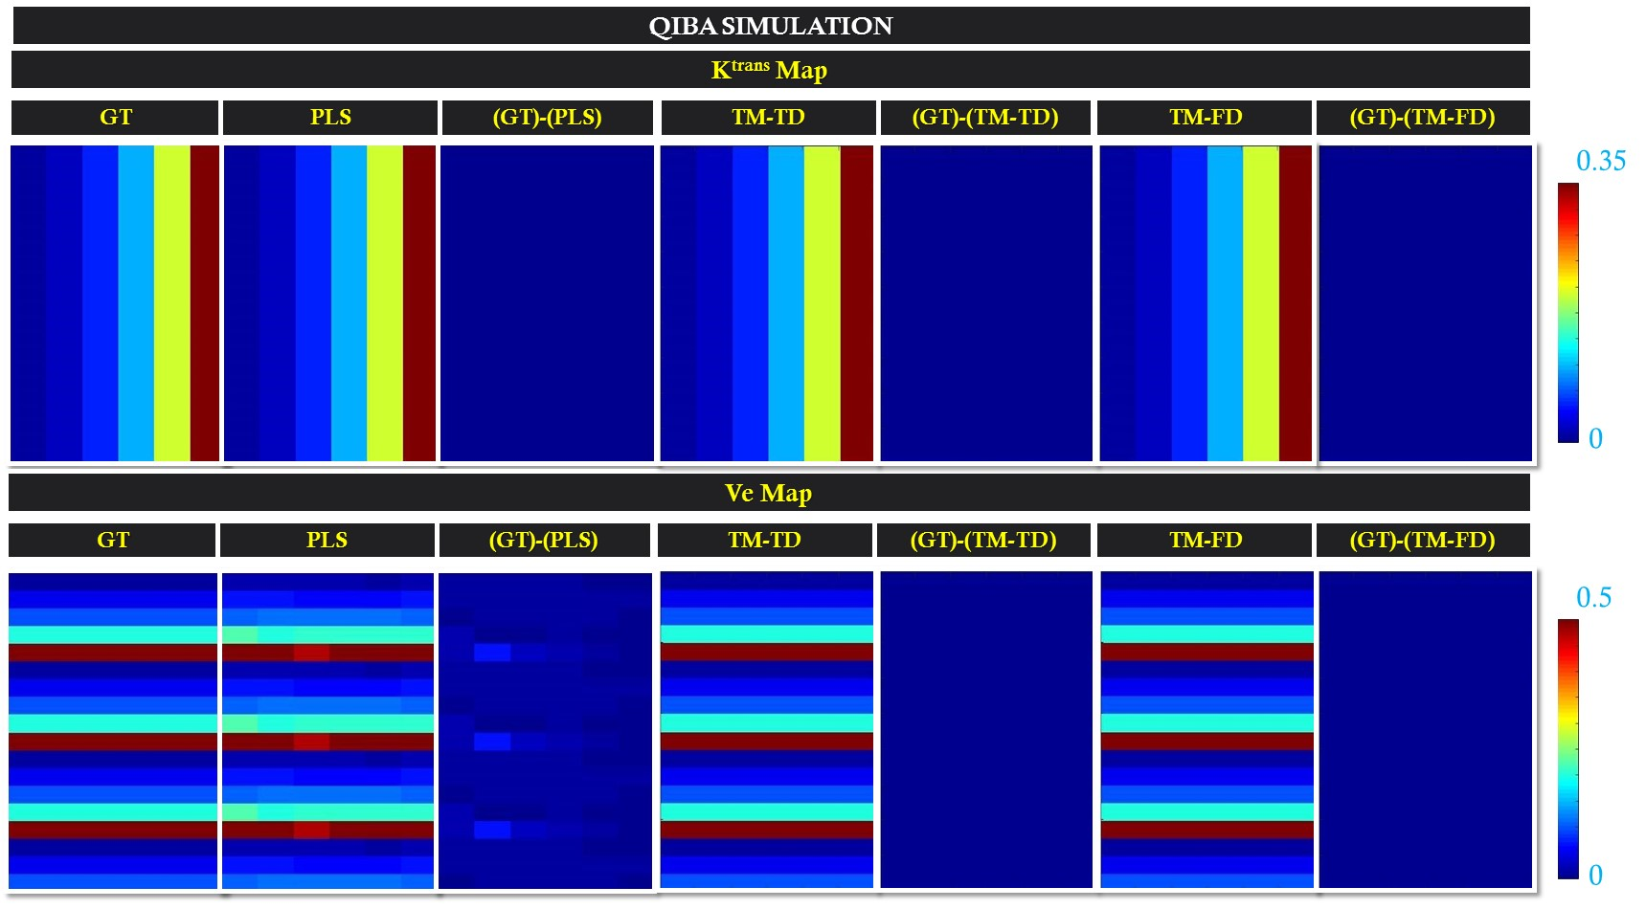

*Figure 6.14(b): Pharmacokinetic maps for In silico simulation of QIBA generated values*

The plots in figure 6.15 shows computational time vs RMSE for QIBA simulated data and Random simulated data

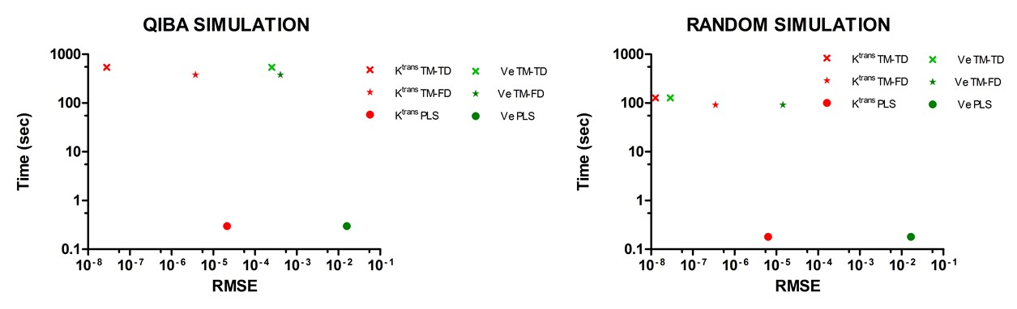

*Figure 6.15: Performance evaluation on In silico simulation*

Dictionary of CTCs was generated using 1000 K trans and 1000 Ve values ranging between 0.001 – 1 (equally spaced step size) and was taken as ground truth (GT) to obtain β. Averaged population based Arterial Input Function was used from [16] to employ the forward simulation by taking 32 time points with temporal resolution of 5s to generate the CTCs. The β coefficient was obtained by using these forward simulated CTCs and randomly generated Pharmacokinetic maps (K trans and Ve). The β thus obtained was utilized to obtain the K trans  and Ve maps and the approach was named TM-TD PLS.

β coefficient obtained for the random and QIBA simulation was used for TM-TD PLS to obtain PK maps for all simulation datasets. CTCs were fit for two parameters (KTrans and Ve) using TM-TD, TM-FD and TM-TD PLS.

Figure 6.16(a) shows Pharmacokinetics maps from TM-TD, TM-FD, TM-TD PLS and TM-FD PLS on the seven breast data set from QIN for (a) Ktrans and (b) Ve with difference map and Figure 6.16(b) shows comparison of computation time for TM-TD, TM-FD and PLS for seven breast DCE data.

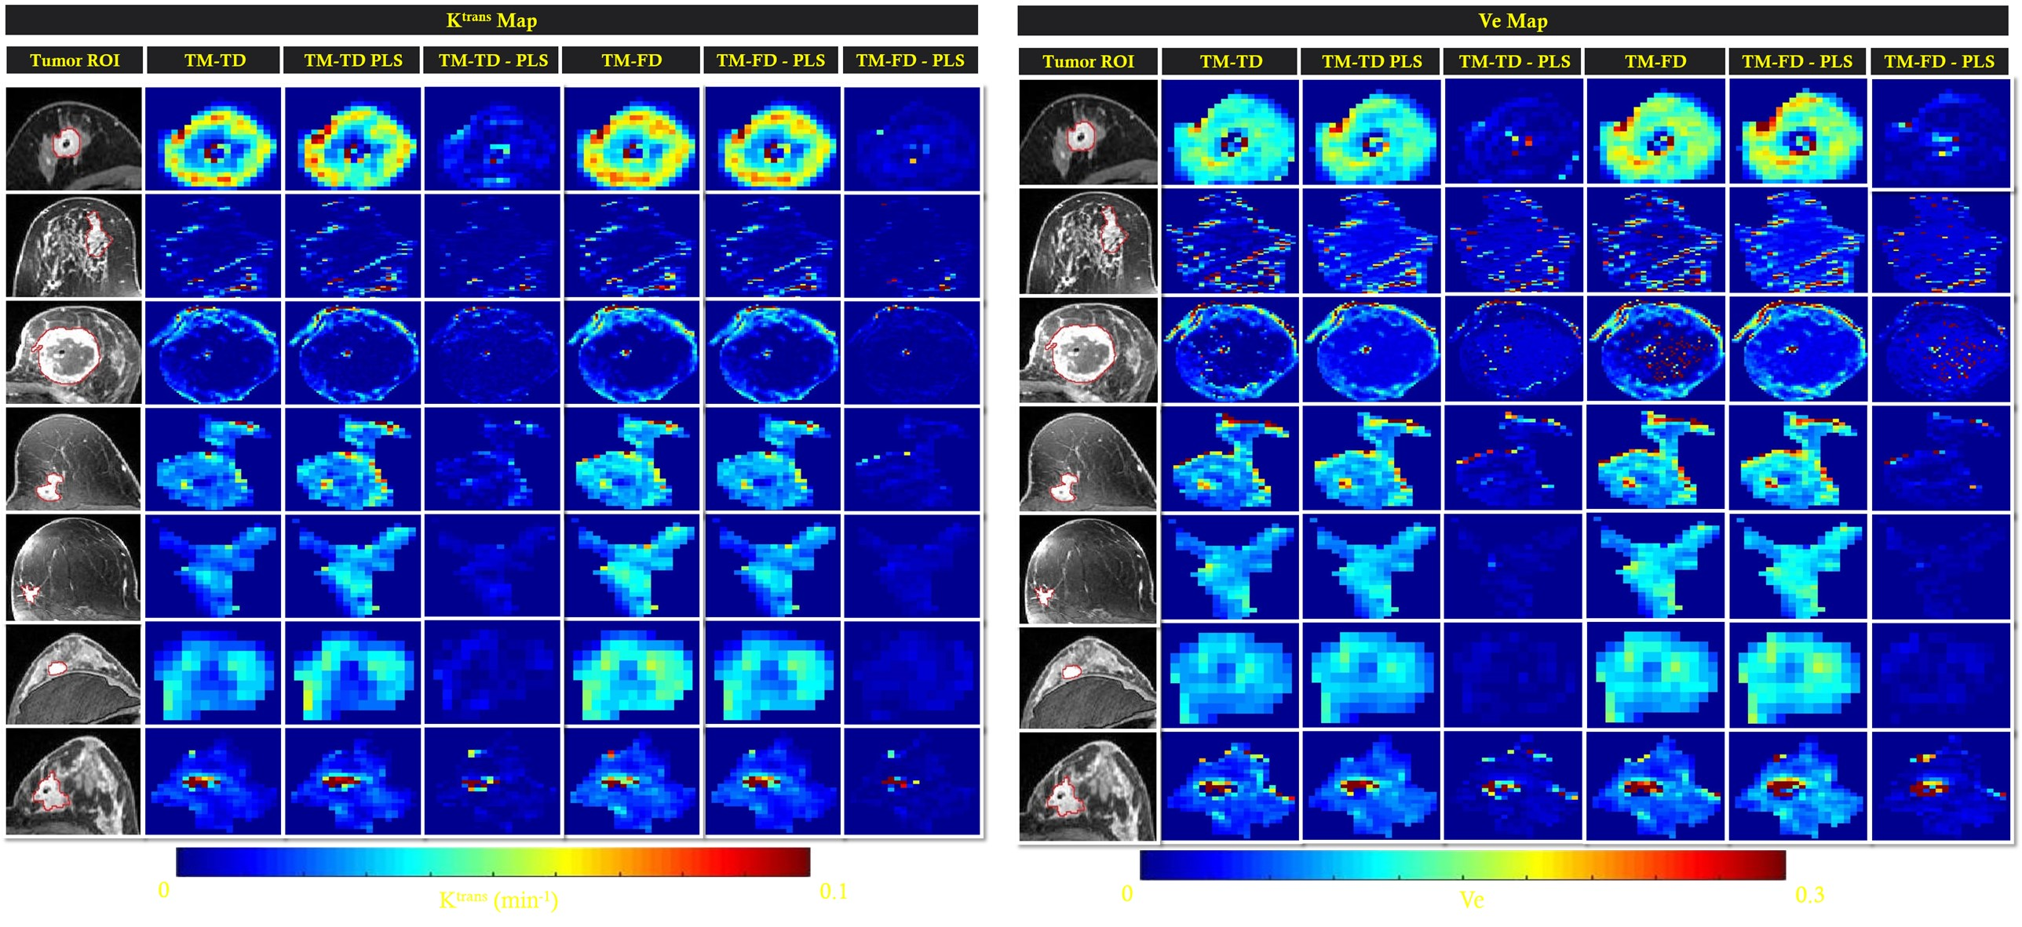

*Figure 6.16(a): Pharmacokinetic maps for In vitro data*

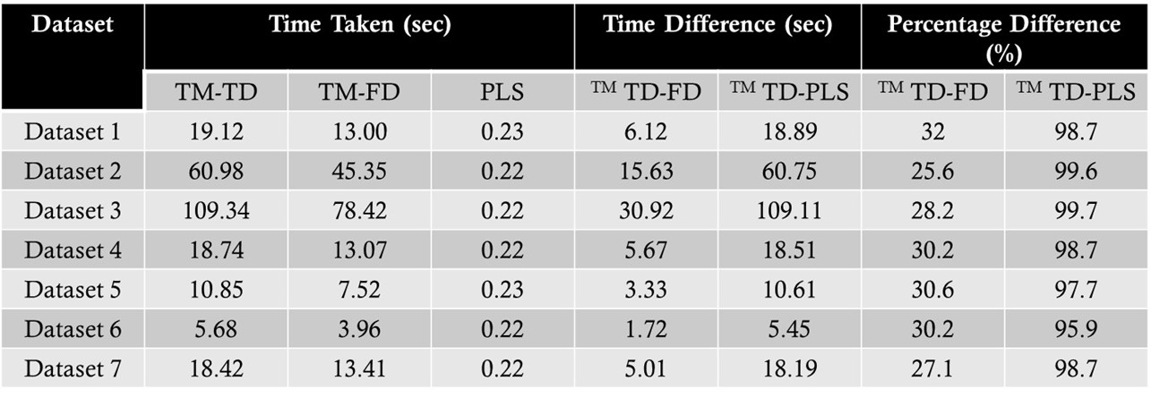

*Figure 6.16(b): Comparison of computation time for TM-TD, TM-FD and PLS for seven breast DCE data*

**6.3.2 Dynamic-susceptibility contrast (DSC) MRI**

Dynamic-susceptibility contrast (DSC) MRI is a very powerful technique that provides important information regarding cerebral hemodynamic parameters like Cerebral blood volume(CBV) , Cerebral blood flow(CBF) and mean transit time (MTT) etc. DSC MRI is used in rapid assessment of the brain hemodynamic as it provides relatively high CNR, fast acquisition (less than 1 minute)[17].

Main five steps used in obtaining DSC MRI parametric maps are as below**:**

1. Acquisition of DSC-MRI images, with signal intensity *s(t)*
2. Conversion of *s(t)* to contrast agent concentration *C(t)*
3. Measurement of arterial input function (AIF)
4. Deconvolution to remove AIF contribution from the tissue
5. Scaling the hemodynamic parameters to absolute units

The flowchart shown in figure 6.17 shows workflow of DSC MRI for generating parametric maps.

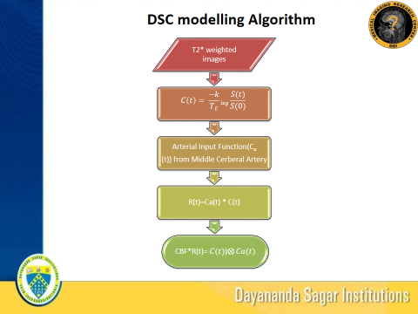

Figure 6.17: Flowchart for DSC-MRI

Different parametric maps obtained on reading DSC data and selection of slice followed by measuring tissue concentration curve (*c(t)).*Integral of *c(t)* gives CBV.AIF from highest SI voxel was measured from Middle cerebral Artery. SVD was performed, using

*c(t)= Ca(t) * R(t) (9)*

where R(t) is residual function. Concentration time curve(CTC) mean transit time (MTT),AIF,CBV and CBV maps were computed and summarized in figure 6.18.

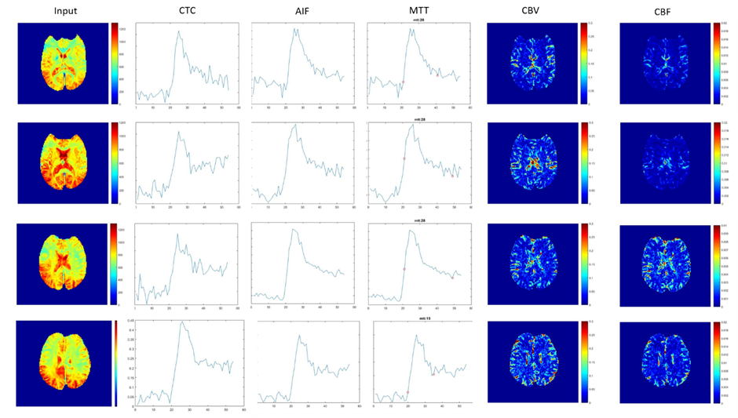

Figure 6.18: DSC-MRI parametric maps

**6.4 Motion correction in MRI**

MRI provides excellent soft-tissue contrast with no effects of ionization as compared to other imaging modalities such as X-ray, CT and PET. MRI has prolonged acquisition time that makes images susceptible to motion artifacts [1]. MRI motion reduction and/or compensation is an active area of research [18]. Motion primarily induces ghosting and blurring artifacts in the images [19, 20]. Patient/ subject motion typically includes physical motion and internal organ motion. The motion artifacts can be corrected in spatial domain and/or in frequency domain. The state-of-art motion correction methods include use of MR navigators, respiratory triggering, breath held scans and retrospective motion correction [18]. MR navigators increase total scan time and respiratory triggering typically needs multiple scans to obtain motion free scan images [18].

**6.4.1 In-vitro motion correction**

It is well established that high frequency components get more distorted than low frequency components during motion [18, 21. Typically, in the case of MSK MRI, the extent of motion is estimated from orthogonal acquisitions rather than measured in real time (real time measurements) [22]. The extent of motion is given by eq. (1) below, wherein 𝛝 represents the velocity of the object under motion during time 𝛕 between two k-space lines and 𝛃 being the angle between the vectors k.

$J=e^{(-\frac{1\left(k1+k2\right)}{2})ϑ*τcos\left(β\right))}$ (10)

Equation (10) can be rewritten to indicate displacement of the object considering the displacement vector as the product of velocity and time represented by r as in equation (11)

ϑ*τ=r (11)

Substituting (11) in (10),

$J=e^{(-\frac{1\left(k1+k2\right)}{2})r*cos\left(β\right))}$ (12)

The experiments were carried out on a Siemens 1.5T Magnetom Avanto scanner with TR/TE-500/12ms, pulse sequence- spin echo, Averages- 1, Slice thickness-5mm, matrix size- 256X128 with resolution of 1mm2 isotropic. The external tracking device used was a DSLR camera. The camera was setup at a distance of 300cm away from the scanner with camera focusing at the bore of the MR scanner. The camera was placed on a tripod at full magnification with a spatial resolution of 1920 x 1080 and temporal resolution of 20 frames per second (fps). A checkerboard was used as external marker for motion detection as the edges of the squares provide significant contrast for edge detection to track motion. The DSLR camera provided information of the time of displacement and the known extents of motion (0.5 cm to 2cm incrementing in steps of 0.5cm) induced midway during the scan in both horizontal and vertical directions, corresponding to sagittal and coronal motion respectively. Pixel shifts induced due to motion were measured using cross-correlation of the post-motion images with those of pre-motion.

The results of the motion correction performed for in vivo multichannel phantom data is shown in figure 6.18. It can be qualitatively assessed that the motion corruption that can be noticed in the top row of figure 5 has been significantly mitigated in the motion corrected data shown in the bottom row. It can also be observed that the data corruption increases with increase in displacement as expected. The loss of edge information in the top row has been retrieved in the bottom row. However, it must be noted that there are residual artifacts neighbouring the original object in the case of phantom experiment

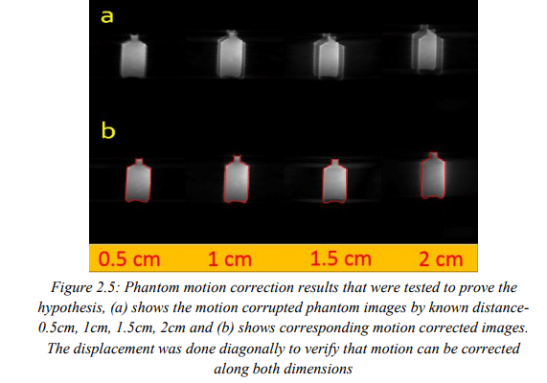

*Figure 6.18: The phantom results that were tested to prove the hypothesis, (a) shows the motion corrupted phantom to known distance -0.5 cm, 1cm.1.5cm and (b) shows corresponding motion corrected images .The displacement was done diagonally to verify that motion can be corrected along both directions*.

Figure 6.18 shows the phantom results that were tested to prove the hypothesis. Figure (a) shows the motion corrupted phantom to known distance -0.5 cm, 1cm.1.5cm. Figure (b) shows corresponding motion corrected images .The displacement was done diagonally to verify that motion can be corrected along both directions.

**6.4.2 In-vivo motion correction**

The results of in vivo MSK experiment on six different subjects can be seen in figure 6.19 and as expected it can be observed that the extent of motion artifact in each of the six different subject is different. In addition to increasing the signal to noise ratio, the technique also demonstrates the ability to restore the edge information which is lost due to motion. However, smoothening of certain areas such as that pointed by the yellow arrows in figure 2.24 is introduced due to motion correction which can be attributed to sudden changes in phase over a small physical distance that is not captured by the current setup.

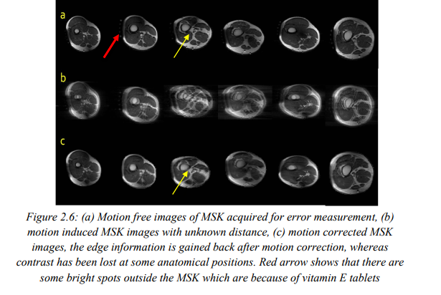

*Figure 6.19 (a) Motion free images of MSK acquired for error measurement, (b) motion induced MSK images with unknown distance,(c)motion corrected MSK images, the edge information is gained back after motion correction, whereas contrast has been lost at some anatomical positions. Red arrow shows that there are some bright spots outside the MSK which are because of vitamin E tablets*

**6.4.4 Error quantification**

The NRMSE calculation for quantitative analysis of six dataset of healthy volunteers without motion (motion free) is shown in figure 6.20. The plot demonstrates that the NRMSE values of motion corrected data set is reduced compared to the motion corrupted data set. It can be seen that the error factor introduced when the experiment is repeated thrice is computed by the mean and standard deviation for each data.

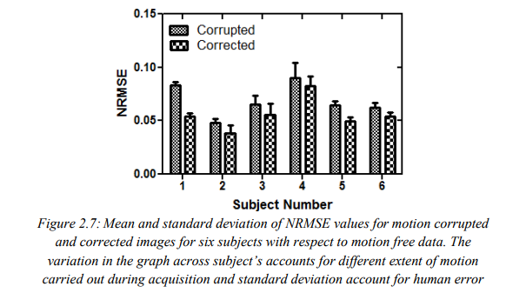

*Figure 6.20: Mean and standard deviation of NRMSE values for motion corrupted and NRMSE values for motion corrupted and corrected images for six subjects with respect to motion free data. The variation in the graph across subject’s accounts for different extent of motion carried out during acquisition and standard deviation account for human error*

**6.4.5 Motion modelling**

Fused images of motion free with motion corrupted and motion free with motion corrected were obtained for qualitative analysis of a representative data set by juxtaposing patches from the motion free (white squares from figure 6.21(d)), motion corrupted (black squares from figure 6.21 (d)), and motion corrected images (black squares from figure 6.21 (d)) respectively. A misregistered image with poor edge delineation is observed in fused image obtained by fusing motion free and motion corrupted images whereas this is significantly improved in the fused image of motion free and motion corrected image.

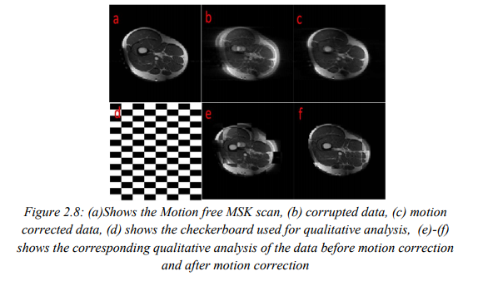

*Figure 6.21 (a) shows the motion free MSK scan, (b)corrupted data,(c)motion corrected data,(d)shows the checker Board used for qualitative analysis, (e) – (f) shows the corresponding qualitative analysis of the data before motion correction and after motion correction*

A Graphical User Interface (GUI) including manual and automated MR motion correction built using Matlab Guide can be seen in figure 6.22. The GUI can be used to both simulate and correct for motion in MR images. The motion correction and simulation is implemented for both 1D and 2D motion correction.

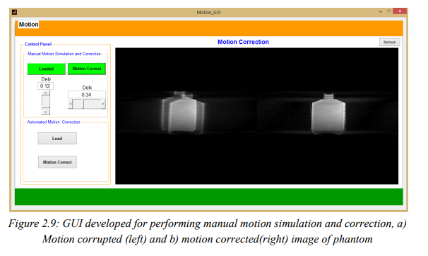

*Figure 6.22: GUI developed for performing manual simulation and correction, a) Motion corrupted (left) and b) motion corrected (right) image of phantom*

The automated motion correction uses gradient entropy of the image to correct for motion artifact. The user input for Region of Interest (ROI), to be corrected is necessary to correct for the motion artifact in automated motion correction. Figure 6.23 shows the automated motion correction and ROI selected by user on a gradient of image to be corrected.

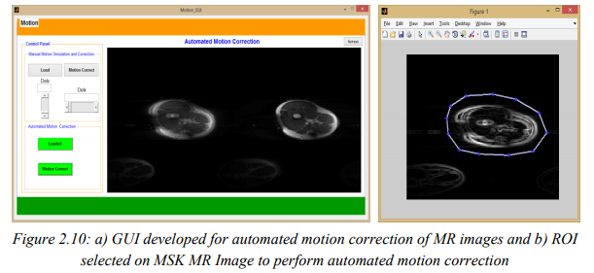

*Figure 6.23:a) GUI for automated motion correction of MR images and b)ROI selected on MSK MR image to perform automated motion correction*

**References**

1. Pamela W. Schaefer “Diffusion-weighted MR Imaging of the Brain”, in Radiology; 217:331–345 (2000)
2. Vajuvalli, N.N., Chikkemenahally, D.K.K., Nayak, K.N., Bhosale, M.G. and Geethanath, S., The Tofts model in frequency domain: fast and robust determination of pharmacokinetic maps for dynamic contrast enhancement MRI. Physics in medicine and biology, vol.61, no.24, pp.8462,2016.
3. Zaitsev M, Maclaren J, Herbst M, “Motion artifacts in MRI: A complex problem with many partial solutions” J Magn Reson Imaging, 10.1002/ jmri.24850, Jan 28, 2015.
4. Le Bihan, D., Mangin, J.F., Poupon, C., Clark, C.A., Pappata, S., Molko, N. and Chabriat, H., “Diffusion tensor imaging: concepts and applications”. Journal of magnetic resonance imaging, vol.13,no.4, pp.534-546,2000.
5. Kingsley, P.B., “Introduction to diffusion tensor imaging mathematics Part I. Tensors, rotations, and eigenvectors”, Concepts in Magnetic Resonance Part A, vol..28,no.2, pp.101-122, 2006
6. Calamante, F., Gadian, D.G. and Connelly, A., Delay and dispersion effects in dynamic susceptibility contrast MRI: simulations using singular value decomposition. Magnetic resonance in medicine, vol.44,no.3, pp.466-473,2000.
7. Malamateniou. C, Malik S J, Counsell S J, Allsop J M, MC Guinness A K, Nunes R G, Ederies A M, Hajnal J V, Ruderford M A “Motion, Compensation Techniques in Neonatal and Fetal MR Imaging” AJNR, 34 (6) b: 1124-36, Jun-Jul 2013
8. [Osamu Togao](https://www.ncbi.nlm.nih.gov/pubmed/?term=Togao%20O%5BAuthor%5D&cauthor=true&cauthor_uid=26243792), [Akio Hiwatashi](https://www.ncbi.nlm.nih.gov/pubmed/?term=Hiwatashi%20A%5BAuthor%5D&cauthor=true&cauthor_uid=26243792), [Koji Yamashita](https://www.ncbi.nlm.nih.gov/pubmed/?term=Yamashita%20K%5BAuthor%5D&cauthor=true&cauthor_uid=26243792), [Kazufumi Kikuchi](https://www.ncbi.nlm.nih.gov/pubmed/?term=Kikuchi%20K%5BAuthor%5D&cauthor=true&cauthor_uid=26243792), [Masahiro Mizoguchi](https://www.ncbi.nlm.nih.gov/pubmed/?term=Mizoguchi%20M%5BAuthor%5D&cauthor=true&cauthor_uid=26243792), [Koji Yoshimoto](https://www.ncbi.nlm.nih.gov/pubmed/?term=Yoshimoto%20K%5BAuthor%5D&cauthor=true&cauthor_uid=26243792), [Satoshi O. Suzuki](https://www.ncbi.nlm.nih.gov/pubmed/?term=Suzuki%20SO%5BAuthor%5D&cauthor=true&cauthor_uid=26243792), [Toru Iwaki](https://www.ncbi.nlm.nih.gov/pubmed/?term=Iwaki%20T%5BAuthor%5D&cauthor=true&cauthor_uid=26243792), [Makoto Obara](https://www.ncbi.nlm.nih.gov/pubmed/?term=Obara%20M%5BAuthor%5D&cauthor=true&cauthor_uid=26243792), [Marc Van Cauteren](https://www.ncbi.nlm.nih.gov/pubmed/?term=Van%20Cauteren%20M%5BAuthor%5D&cauthor=true&cauthor_uid=26243792), and [Hiroshi Honda](https://www.ncbi.nlm.nih.gov/pubmed/?term=Honda%20H%5BAuthor%5D&cauthor=true&cauthor_uid=26243792) ,”Differentiation of high-grade and low-grade diffuse gliomas by intravoxel incoherent motion MR imaging”,  Neuro-oncology, 18(1), pp.132-141, 2015
9. JPB O’Connor et al., “DCE-MRI biomarkers in the clinical evaluation of anti-angiogenic and vascular disrupting agents,” British Journal of Cancer (2007) 96, pp. 189-195, Jan. 2007
10. Thomas E. Yankeelov et al., “Quantitative pharmacokinetic analysis of DCE-MRI data without an arterial input function: a reference region model,” Magnetic Resonance Imaging 23, pp.519–529, Feb. 2005
11. Roberta Fusco, “Lesion detection and classification in breast cancer: evaluation of approaches based on morphological features, tracer kinetic modelling and semi-quantitative parameters in MR functional imaging (DCE-MRI),” Ph.D. dissertation, Department of Biomedical Engineering, University of Bologna
12. <https://dblab.duhs.duke.edu/modules/QIBAcontent/index.php?id=1>
13. Geoff J.M. Parker, Caleb Roberts, Andrew Macdonald, Giovanni A. Buonaccorsi, Sue Cheung, David L. Buckley, Alan Jackson, Yvonne Watson, Karen Davies and Gordon C. Jayson,” Experimentally-derived functional form for a population-averaged high-temporal- resolution arterial input function for dynamic contrast-enhanced MRI Magnetic Resonance in Medicine ”, No.56, pp 993–1000, OCT 2006
14. Calamante, F., Gadian, D.G. and Connelly, A., Delay and dispersion effects in dynamic susceptibility contrast MRI: simulations using singular value decomposition. Magnetic resonance in medicine, vol.44,no.3, pp.466-473,2000.
15. Malamateniou. C, Malik S J, Counsell S J, Allsop J M, MC Guinness A K, Nunes R G, Ederies A M, Hajnal J V, Ruderford M A “Motion, Compensation Techniques in Neonatal and Fetal MR Imaging” AJNR, 34 (6) b: 1124-36, Jun-Jul 2013.
16. Wood M L, Henkelman R M, “MR Image Artifacts from Periodic Motion” Med Phys; 12:143: 151, 1985.
17. Van de Walle R, Lemahieu I, Achten E “Magnetic Resonance Imaging and the reduction of motion artifacts: review of the principles ” Technol Health Care; 5:419:435, 1997.
18. M. Zatsev, C. Dold, G. Sakas, J. Hennig and O. Speck “Magnetic Resonance Imaging of freely Moving Objects : Prospective real- time Motion Correction using an External Optical Motion tracking System” 31 (3) : 1038-50, Jul, 2006.
19. Gholipur A, Polak M, Van der Kouwe A, Nevo E, Warfield S K, “Motion-Robust MRI through real-time motion tracking and retrospective super- Resolution Volume Reconstruction” Conf Proc IEEE Eng Med Biol Soc. 5722-5, 2011.
20. Edward Brian Welch, Joel P Felmlee, Richard L Ehman and Armando Manduca “Motion Correction Using The K-Space Phase Difference Of Orthogonal Acquisitions” Magn Reson Med 48:147–156 (2002).
21. Matthias Weigel. “Extended Phase Graphs: Dephasing, Rf Pulses,And Echoes - Pure And Simple” Journal Of Magnetic Resonance Imaging (2014)
22. Zaitsev M, Maclaren J, Herbst M, “Motion artifacts in MRI: A complex problem with many partial solutions” J Magn Reson Imaging, 10.1002/ jmri.24850, Jan 28, 2015.

indexsmart.mirasmart.com/ISMRM2017/PDFfiles/2902.html

**1.Correlation of Intra-Voxel incoherent motion (IVIM) imaging and Dynamic**

**Susceptibility Contrast (DSC) MRI for high and low grade gliomas**

Arush Honnedevasthana Arun. Neesha Nagaraj, Nithin Vajuvalli, Jitender Saini, Sairam Geethanath

**Synopsis**

The aim of this study is to validate the feasibility of Intravoxel Incoherent Motion (IVIM) imaging of human brain gliomas; and to differentiate between high grade and low grade gliomas using IVIM parameters (*f, d, D, fD\**)*.* These parameters were then compared to CBV maps obtained through DSC-MRI to evaluate the role of non-contrast agent based perfusion imaging. Results obtained showed that IVIM perfusion fraction *f* could be used to differentiate between high and low-grade brain gliomas

During the medieval period London did not have any authority for maintaining law, it was handled by private investigators called constables or thief takers, as the population of the city increased police force was setup in the year 1829.

Irony in real life is completely different from reel life as shown in dramas where the actors playing the role knows it before hand, while in reality the audience who don’t get irony are those who don’t understand it.

Language is the most important part of communication. It establishes contacts,

**Purpose**

The assessment of perfusion characteristics of tumors using Dynamic Susceptibility Contrast (DSC) has been an important part of clinical diagnosis and evaluation. 1,2 Goal of this work is to study the feasibility of IVIM imaging as compared to DSC on gliomas. This would potentially enable repeated MR imaging of such patient population without the need for contrast administration.

**Methods**

The local Ethics Review Board (ERB) approved the study. Patient data was obtained after oral informed consent. A total of 24 patients with histologically proven cases of glioma were enrolled in this study (18 men and 6 women, mean age 38.8 ± 18.6, range 12-66 years), from February 2015 to May 2016. DSC and IVIM data were acquired on a 3T clinical scanner (Achieva TX, Philips) with an 8-channel head coil. DSC imaging was performed using gadolinium-based agent (gadoterate meglumine) that was intravenously injected at a dose of 0.2 mL/kg of body weight and at a rate of 3 mL/s, followed by a 20-mL saline flush. Standard echo-planar images were consecutively acquired (TR/TE=1950/43 ms, section thickness = 6 mm, acquisition matrix = 128 X 128). CBV, MTT, and CBF maps were computed from the DSC MR imaging data. IVIM imaging was performed using a single-shot spin echo imaging diffusion sequence; with 15 b-values varying from 0 to 900 s/mm2 (0-200: low b-values and 200-900: high b values) in 3 orthogonal directions and the corresponding trace was calculated. Images were acquired in axial plane with a slice thickness of 4mm, an FOV of 230 X 230 mm2, a matrix size of 256 × 256, with in-plane resolution of 0.89 and TR/TE: 4000/105ms. The standard IVIM bi-compartmental diffusion was used to estimate signal attenuation.

A paired t-test was used to evaluate the difference between tumor and contralateral healthy white matter sites on both HGG and LGG cases. The Pearson correlation coefficient ‘*r*’ between IVIM perfusion fraction *f* and DSC CBV was calculated and scatter-plotted for each measure. The box-whiskers plots comparing LGG and HGG were plotted only for parameters obtained from IVIM-DWI. Bland-Altman analysis was used to assess agreement (with 95% limits of agreement) between DSC derived CBV and IVIM derived *f*.

**Results**

Fig 1 shows the representative multi-parametric MR maps for a patient with HGG. The diffusion and pseudo-diffusion maps show a negative correlation. The perfusion fraction *f* and DSC derived CBV maps depict a positive correlation in the right parietal lobe, marked in a yellow ellipse. Fig 2 shows corresponding MR parametric maps derived from IVIM and DSC for a representative LGG patient. The *D* and *fD*\* maps show differences in contrast whereas the *f* and CBV map show hyper intensities in the left parietal lobe. Fig 3 shows the box-whisker plots comparing the four MR parametric maps for the HGG and LGG patients, while showing the range of these values. The perfusion fraction *f* and the flow related parameter *fD*\* showed statistically significant differences (p<0.001) between the two tumor grades, with the LGG showing lesser perfusion than HGG. This information could be used as a biomarker for differentiation between the grades. LGG tumor regions had comparatively similar mean values of *D* as compared to HGG (p=0.90). HGG tumors were characterized by a moderately increased pseudo-diffusion coefficient *D*\* as compared to LGG with no statistically significant difference (p=0.34). Fig. 4a & 4b depicts the differences in the four MR parameters between the two tumor grades and the corresponding contralateral white matter. Both glioma groups showed statistically significant higher *f, D, D\** and *fD*\* values, as reported in earlier studies.3,4 Fig 6 depicts Bland-Altman analyses showing the correlation between DSC derived CBV and IVIM derived *f* maps. The difference ranged from -0.1148 lower LOA to 0.3061 upper LOA. It can be noted that there were no statistically significant difference between them and majority of the measured differences were positive. This shows that the two methods are positively correlated.

**Discussion**

In this study, perfusion fraction *f* values are in reasonable agreement with conventional CBV values obtained from DSC4,5. *D*and FD\** maps suffered from poor signal to noise ratio (SNR). Therefore, the perfusion factor *f* could be a reliable biomarker for differentiation of the two tumor grades.

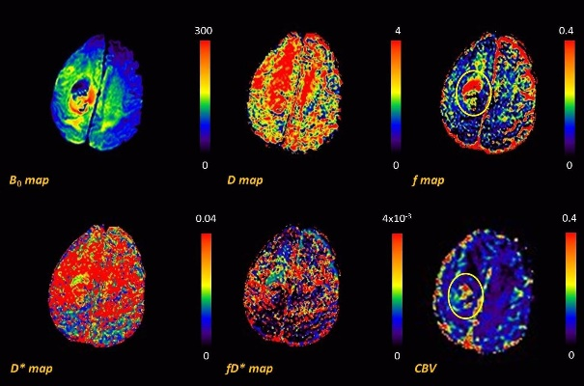

Figure : IVIM parametric maps for HGG patient seen on axial T2-weighted, B0, D, f, D*, fD* and DSC CBV. (scale bars: f unit less; D, D*, fD*: mm2s-1)

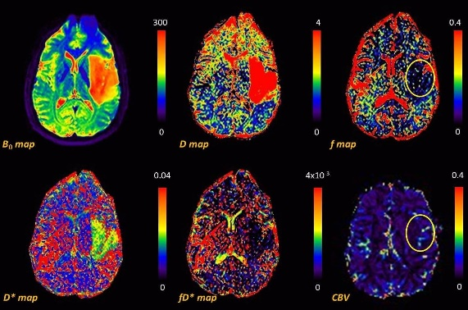

Figure 2: Figure 1: IVIM parametric maps maps for LGG patient seen on axial T2-weighted, B0, D, f, D*, fD* and DSC CBV. (scale bars: f unit less; D, D*, fd*: mm2s-1)

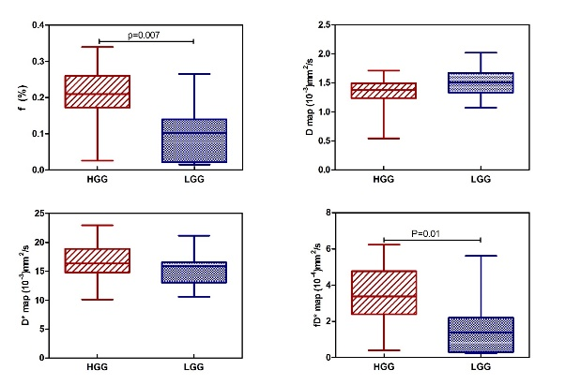

Figure 3: Box-and-whisker plot (median, 25th and 75th percentiles, minimum, maximum, and outliers) of f, D. D* and f D* in HGG and LGG tumours as measured in ROIs of the maximum perfusion fraction.

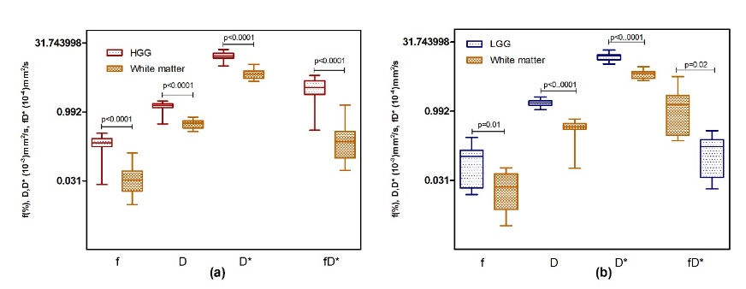

Figure 4: Box-and-whisker plot (median, 25th and 75th percentiles, minimum, maximum, and outliers) of f, D, D*, fD* and white matter in HGG and LGG as measured in ROIs of the maximum perfusion fraction.

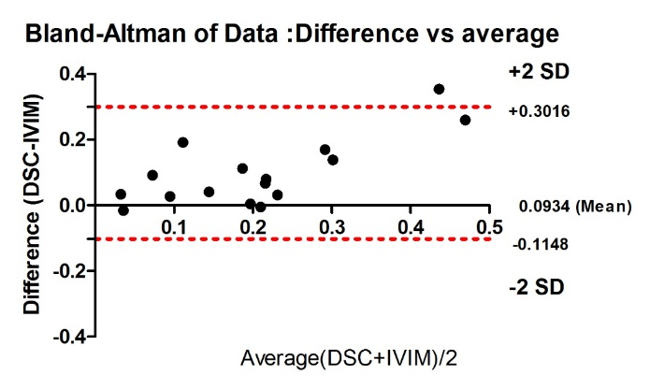

Figure 5: Bland-Altman plots comparing difference between DSC (CBV) and IVIM (f) measurements (CBV – f map) on Y-axis and X-axis represents the average of the measures ((CBV + f map)/2).

**References**

[1] S. Ulmer, C. Liess, S. Kesari, N. Otto, T. Straube, and O. Jansen, “Use of dynamic susceptibility-contrast MRI (DSC-MRI) to assess perfusion changes in the ipsilateral brain parenchyma from glioblastoma,” *J. Neurooncol.*, vol. 91, no. 2, pp. 213–220, 2008.

[2] R. Wirestam, M. Borg, S. Brockstedt, A. Lindgren, S. Holtas, and F. Stahlberg, “Perfusion-related parameters in intravoxel incoherent motion MR imaging compared with CBV and CBF measured by dynamic susceptibility-contrast MR technique.,” *Acta Radiol.*, vol. 42, no. 2, pp. 123–128, Mar. 2001.

[3] C. Federau, P. Hagmann, P. Maeder, M. Müller, R. Meuli, M. Stuber, and K. O’Brien, “Dependence of Brain Intravoxel Incoherent Motion Perfusion Parameters on the Cardiac Cycle,” *PLoS One*, vol. 8, no. 8, pp. 1–7, 2013.

[4] S. Bisdas, T. S. Koh, C. Roder, C. Braun, J. Schittenhelm, U. Ernemann, and U. Klose, “Intravoxel incoherent motion diffusion-weighted MR imaging of gliomas: feasibility of the method and initial results.,” *Neuroradiology*, vol. 55, no. 10, pp. 1189–1196, Oct. 2013.

[5] O. Togao, A. Hiwatashi, K. Yamashita, K. Kikuchi, M. Mizoguchi, K. Yoshimoto, S. O. Suzuki, T. Iwaki, M. Obara, M. Van Cauteren, and H. Honda, “Differentiation of high-grade and low-grade diffuse gliomas by intravoxel incoherent motion MR imaging,” *Neuro. Oncol.*, vol. 18, no. 1, pp. 132–141, 2016.

Proc. Intl. Soc. Mag. Reson. Med. 23 (2015) 1090

Proc. Intl. Soc. Mag. Reson. Med. 23 (2015) 1090

**2.** **Highly Accelerated DCE-MRI Pharmacokinetic map Estimation through frequency domain based Tofts model (HAET)**

Nithin N Vajuvalli1, C K Dharmendra Kumar1, Manoj G Bhosale1,2, and Sairam Geethanath1 *1Medical Imaging Research Centre, Dayananda Sagar College of Engineering, Bangalore, Karnataka, India, 2Government College of Engineering (COEP), Pune, Maharastra, India*

**Target audience:** The current study is relevant to those MR researchers interested in DCE-MRI methods and applications, cancer imaging.I**ntroduction:** Quantitative DCE-MRI is a widely used method for prognosis of cancer. Tofts Model (TM) [1] is an extensively used method for determination of Pharmacokinetics (PK). Curve fitting of concentration time curves (CTCs) for multiple voxels is required for determination of PK maps, which requires long computational time thereby restricting online access to these maps for the radiologist. Hence, there is a need for obtaining PK maps in significantly shorter time. Purpose of this study is to demonstrate a frequency domain (FD) approach in place of existing time domain (TD) approach in order to speed up computational time. **Theory:** The equation for TM in TD is given by ***C(t) = Ktrans*** ***e (-Kept)*Ca(t)*** (1). where C(t) is the concentration of Contrast Agent (CA), Ca(t) denotes Arterial Input Function (AIF) in mM and * denotes convolution operation. The current study solves equation (1) using FD approach and it can be written as in ref [2] as: ***real (Ғ*** ***-1{K}) = real {Ktrans*** ***E (-Kept)}*** (2), Here, K= (K1/K2) where, K1=Ғ{C(t)} and K2=Ғ {Ca(t)} and F here denotes FFT operation while F-1 denotes inverse FFT operation. **Methods and Materials:** *Simulation data:* CTCs were simulated to assess the current FD approach. All the curves were generated with relative Ktrans and Ve of 0.0090~0.14 min-1 and 0.066~0.55 respectively taken form literature [3],

as the Ground Truth (GT) for the evaluation of demonstrated approaches. Average population AIF was used with 28 time points and the CTCs was fit for two parameters (Ktrans and Ve) using TM in TD and TM in FD, which was considered as Estimated Value (EV). The error between the EV and GT value

was determined for the PK maps for both approaches through Normalized Root Mean Square Error (NRMSE). *In-vivo data:* 7 breast DCE data were downloaded from Quantitative Imaging Network (QIN) [4]. Imaging parameters of the data sets were: TR/TE=6.2 ms/2.9ms, temporal resolution 18~20 seconds. Number of time points varied from 28~32 frames in each data sets. The CA used was Gd (HP-DO3A) [ProHance] IV with a dosage of 0.1mmol/Kg at 2 ml/s. Tumor Region Of Interest (ROI) is shown for each data set in yellow outline. CTCs for those ROI pixels were curve fitted for two parameters using both approaches given in equations 1 and 2. Trust-region algorithm was used for curve fitting. The system configuration used to carry out curve fitting was Intel core i5, 2.60 GHz, 4GB RAM and computations were performed using Matlab, Mathworks Inc., Boston, MA. **Performance** **evaluation:** 7 datasets were evaluated for computational time taken for obtaining PK maps using TM-TD and TM-FD approach. Computational timetaken for estimating PK maps for each dataset was evaluated by running five times in both approaches; means and standard deviations were calculated.

NRMSE value was calculated by using equation ***NRMSE=*** Ʃ / ***). /*** (3) for different matrix dimensions of 64x64, 128x128, 256x256, 512x512 with 32 time points, where A is GT, B is the EV from curve fitting of both approaches.

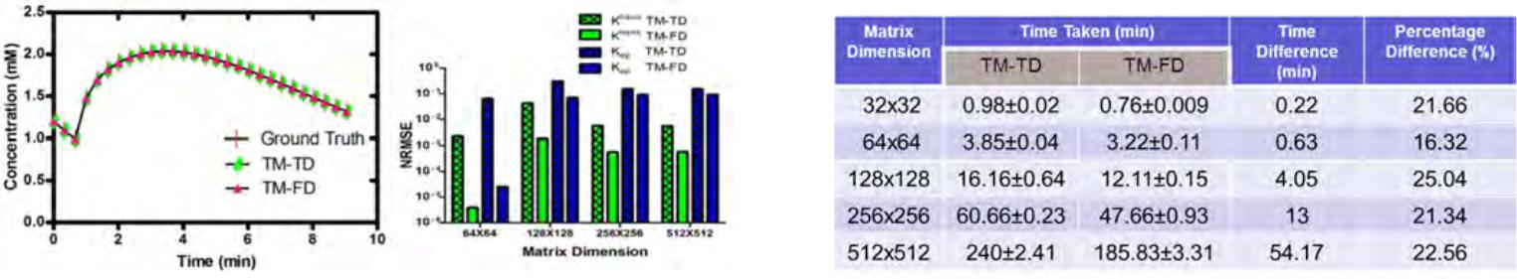

***Figure 1: Comparison between TD and FD approaches, (a) CTCs fitted to model,*** ***Table 1: Time comparison between TM-TD and TM-FD***

***(b) NRMSE values for Ktrans and Kep.***

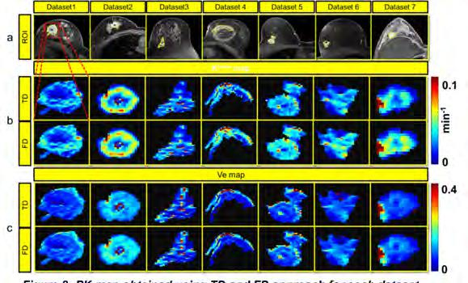**Results and Discussion:** *Simulation results:* Figure 1a depictsexample of CTCs fitting obtained using equations 1 and 2 in simulated

data. The demonstrated TM-FD resulted in similar fitting in comparison to both TM-TD and GT taken. NRMSE graphs for Ktrans and Ve maps of

both approaches, using the output of curve fitting on the original data as GT was measured and plotted in log scale in Figure 1b. The demonstrated TM in FD approach produces lower NRMSE values over the range of different matrix dimension. Table 1 depicts the time taken for curve fitting in min from both approaches indicating strict bounds on the means. It can be observed that there is significantly lesser standard deviation in both approaches demonstrating the Goodness Of Fit (GOF). The simulated data results show a good fit of the demonstrated model with less computational time. *In-vivo data results:* Figure 2a

depicts tumor ROI drawn for breast DCE datasets, 1st column of Figure 2b and Figure 2c depicts the ktrans and Ve maps of the tumor of dataset

|  |  |  |
| --- | --- | --- |
| 1 respectively (shown as magnified version in red outline) using TM in TD | ***Figure 2: PK map obtained using TD and FD approach for each dataset*** |  |
|  |  |

and TM-FD and so on. TM in FD was able to reproduce similar PK maps as that to TM in TD with lesser computational time taken.

**Conclusion:** Accelerated determination of PK maps using TM in FD was achieved and could reliably substitute for TM in TD with significantly lesser computational time. Current and future work involves applying of this approach to other existing models like Extended Tofts Model (ETM) and subsequent radiological evaluation (blind).

**References:** [1] Steven P. Sourbron et al, MRM 2011 [2] Nithin N Vajuvalli et al, IEEE EMBS, 2014 [3] Wei Huang et al, Translational Oncology 2014 [4] michallenges.org/dceChallenge2/clinical.html. **Acknowledgement:** Dattesh D shanbhag, GE ITC, Bangalore for helpful discussions.

*Critical Reviews™ in Biomedical Engineering,* 44(4):243–254 (2016)

**A Review of Point-Wise Motion Tracking Algorithms for Fetal Magnetic Resonance Imaging**

Sairam Geethanath

Medical Imaging Research Centre, Dayananda Sagar Institutions, S.M. Hills, Kumarswamy Layout, Bangalore-560078, India; Tel.: +91-9448293026; Fax: 080-26660789, E-mail: sairam.geethanath@dayanandasagar.edu

**ABSTRACT:** We review recent feature-based tracking algorithms as applied to fetal magnetic resonance imaging(MRI). Motion in fetal MRI is an active and challenging area of research, but the challenge can be mitigated by strate-gies related to patient setup, acquisition, reconstruction, and image processing. We focus on fetal motion correction through methods based on tracking algorithms for registration of slices with similar anatomy in multiple volumes. We describe five motion detection algorithms based on corner detection and region-based methods through pseudocodes, illustrating the results of their application to fetal MRI. We compare the performance of these methods on the basis of error in registration and minimum number of feature points required for registration. Harris, a corner detection meth-od, provides similar error when compared to the other methods and has the lowest number of feature points required at that error level. We do not discuss group-wise methods here. Finally, we attempt to communicate the application of available feature extraction methods to fetal MRI.

**KEY WORDS:** fetal motion correction, magnetic resonance imaging, feature detection, point-wise detection andtracking

**I. INTRODUCTION**

Magnetic resonance imaging (MRI) is a noninva-sive imaging modality that does not involve ioniz-ing radiation, has no known associated negative side effects,1 and is a well-established imaging modality in the field of medical diagnostics.2 Fetal MRI is used as a complementary imaging modality to ultra-sound.1 Fetal MRI provides increased information content typically during the evaluation of abnormal-ities pointed out by ultrasonography and/or in cases of neuropathologies of the fetus.3 Unfortunately, longer scan time in MRI results in motion-induced artifacts that translate into inaccurate biometrical measures and/or clinically unacceptable images. This challenge of motion in fetal MRI is typically addressed through patient setup, acquisition, recon-struction, postprocessing, or a combination of these.

**A. Prospective Motion Correction of Fetal**

**MRI**

Patient preparation, patient coaching, and seda-tion (if required) are necessary for preventing mo-tion artifacts during magnetic resonance (MR) fetal scanning.4,5 Typically, patient preparation in-

cludes comforting a patient using pillows, foams, and sand bags. Artifacts typically occurring in fetal

MRI include bulk fluid motion and partial volume.

The procedure for fetal scanning and other types of commonly occurring artifacts during fetal scan-ning are described in detail elsewhere.6 A popular method of choice to overcome motion prospectively is the use of navigators, which are lines in *k*-space that are acquired as references during scan time.4 Navigators, as opposed to untriggered techniques, determine the accuracy of real-time navigator-echo– based acquisition correction. Untriggered methods typically include fast imaging or sedation methods. Navigator-echo acquisitions help to identify struc-tural brain abnormalities,6 and the accuracy of these methods is reported to have improved from 50% to 90%.6 Spiral, radial, and propeller trajectories are self-navigated sequences that occur as a result of repeated sampling at the center of *k*-space (low-spatial-frequency components). This redundant in-formation can be used to address motion correction. It has been shown that the propeller technique can address in-plane (but not through-plane) motion artifacts.4,7,8 Fetal motion includes motion of both subject and fetus. Subject motion can be detected

0278-940X/16/$35.00  © 2016 by Begell House, Inc. **243**

**244** Geethanath

and corrected with the use of MR-compatible cam-eras, infrared markers, lasers, detectors, and optical markers.9 Fast and motion-resistant sequences such as balanced steady-state free precession cine have been optimized for fetal imaging.10 Fast spin echo (FSE) is a widely used sequence for fast imaging, but it is prone to motion artifacts due to relatively longer acquisition time.4 Recent developments in the fields of hardware and software have made FSE possible for fetal imaging in clinical practice. Fast imaging sequences such as fast low-angle shot, echo planar imaging, FSE, single-shot FSE (SSFSE), and half-Fourier single-shot turbo spin echo have been prospectively demonstrated in fetal imaging for re-duction of motion.11 Compressed sensing (CS) is an acquisition-reconstruction method illustrating that a sparse representation of data can be recovered by randomly sampling *k*-space data.12,13 Interpolated CS has been applied to fetal MRI for reducing ac-quisition time for multislice fetal MRI.14,15 Iterative motion correction has been demonstrated between two two-dimensional (2D) acquisitions. The method was then combined with super-resolution and an in-tensity correction step to obtain the isotropic resolu-tion volume of the fetal brain.16

**B. Motion Correction through Postprocessing for Fetal MRI**

Fetal brain volumetry has been quantified using state-of-art motion correction techniques between 2D slices.17 A framework combining segmentation and reconstruction has also been developed. The frame-work consists of an automated method to mask fetal brain as a preprocessing step for motion correction and to align 2D slices to obtain three-dimensional (3D) probabilistic segmentations of brain.18 Gholi-pour et al. have developed a method that exploits the slice acquisition model for enabling reconstruc-tion of multislice acquisition. Here, super-resolution volume reconstruction is projected as an inverse problem to determine the underlying structure gen-erating acquired slices.19 Single-shot imaging with volume reconstruction (SVR) has been widely used for fetal brain reconstruction.20 SVR relies on the as-sumption that the anatomy does not change shape or size and moves at a deterministic rate. SVR applica-

tion for fetal brain imaging reveals the fine structure of an *in-utero* fetal brain clearly for the first time and demonstrates substantial signal-to-noise ratio improvement.20

Rousseau et al. have proposed a technique to obtain single isotropic resolution of the fetal brain that uses iterative-based techniques to correct mo-tion between two slices.21 In addition, Kim et al. pro-posed slice intersection motion correction.22 Their method considers matching structure to coalign multiple slice stacks along intersecting slice pairs in all orthogonal slices into a match along their lines of intersection. Kuklisova-Murgasova et al. proposed a method for fetal brain reconstruction. Their method uses slice-to-volume registration to correct for mo-tion. It excludes misregistered or corrupted voxels, slices based on intensity matching, and robust sta-tistics to achieve super-resolution.23 An accelerated reconstruction framework was proposed for motion correction based on multi-GPU (Graphical Process-ing Unit).24 The additional features of the frame-work are automated rejection of outliers.24 These techniques typically use digital image-processing algorithms that estimate and/or compensate for mo-tion.

This review evaluates five point-wise motion es-timation and correction methods in fetal MRI using corner- and region-based algorithms. The algorithms that we consider are (1) features from accelerated segmented test (FAST),25 (2) MinEigen,26 (3) maxi-mally stable external region (MSER),27 (4) speeded up-robust features (SURF),28 and (5) Harris.29

**II. ALGORITHMS**

**A. FAST**

FAST, a corner feature detector algorithm, detects the feature points in a real-time frame rate using a mobile robot with minimum computational resourc-es.25 Corner detection is performed on an image by considering pixel *p* with intensity *Ip* surrounded by *n* pixels (e.g., *n* = 16 for a Bresenham circle witha radius of 3). A constraint of 12 contiguous pixels subject to a particular threshold *T* is applied. *p* is considered to be positive if the constraint is satis-fied and negative otherwise. The performance of

*Critical Reviews™ in Biomedical Engineering*

|  |  |
| --- | --- |
| Point-Wise Motion Tracking Algorithms for Fetal MRI | **245** |

the algorithm was improved by comparing intensity value of only those pixels located in the center of the edges of the square neighborhood (for a Bresenham circle with a radius of 3, edge center pixels are the first, fifth, ninth, and 13th pixel around *p*). A feature is detected if a set of three out of four pixels is ei-ther above or below *T*. The procedure was repeated for all of the pixels in the image, and the number of contiguous pixels for optimal performance of the algorithm was determined to be 12.25 FAST has been applied in 3D model-based tracking,2 machine learning,30 action detection, and spatiotemporal fea-ture extraction.31,32 Because FAST is used in the field of spatiotemporal feature detection,31,32 it could be applied to fetal MRI, where similar challenges exist.

**Pseudocode for FAST Algorithm**

**Input:** Image

**Output:** Set of feature points detected

**SET:** *p*as pixel to be determined as feature pointor not

**SET:** Threshold*T*for intensity value

**COMPUTE:** Number of pixels around*p*, usingBresenham circle

**SET:** Number of pixels*N*around*p*that shouldsatisfy threshold condition

**if** the set of all three-edge pixels*e1*,*e2*,*e3*,*e4*of the square neighborhood of *p* are > or < *T*

SET *p* as feature point

**else if** all contiguous*N*pixels around*p*> or <*T* **SET** *p*as feature point

**else**

SET *p* as negative point

**REPEAT:** Above steps for all pixels

**B. MSER**

An extremal region, defined as a set of image el-ements that indicate the correspondence between two images, contains properties of continuous image coordinate transformation and monotonic image intensity transformation. MSER is a fast

detection algorithm based on subsets of extremal regions.33 These regions are defined by an extremal property of the intensity function in the region and on its boundary. MSER algorithm implementation can be divided into four major steps: preprocess-ing, clustering, detecting MSER, and displaying results.

***1. Preprocessing***

Pixels are sorted in order of intensity, and the num-ber of pixels at each intensity level is determined. The sorting can be performed using a sorting algo-rithm or by finding the intensity histogram and pro-viding that as an input to the sorting algorithm. The histogram reduces computational complexity for sorting because it minimizes the shuffling of data.

***2. Clustering***

The union-find algorithm34 is used to keep track of regions of connected pixels as well as the size of each such region. A region map (RM) is defined as the memory used by the algorithm for pixel map-ping. Each location at the RM holds a number *U*, interpreted as

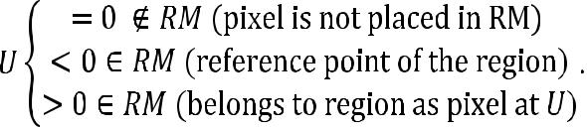

***3. Detecting MSER and Displaying Results***

MSER is determined by computing the stability metric *q*(*i*) per Eq. (1) below. The stability metric of the neighboring pixel (*q*(*i* + 1)) is calculated and compared to stored *q*(*i*) and *dq*/*di* to determine a local minimum. If *q*(*i* + 1) is greater than *q*(*i*) and *dq*/*di* is negative, a local minimum is found at *q*(*i*).Finally, *q*(*i* + 1) and the new *dq*/*di* is copied to the *Q*-memory. Linked regions35have an additionalfield, termed a link field, which holds the pointer. Pixels belonging to the same regions are traced us-ing pointers, and linked fields are swapped between two reference points if two regions merge. Linked regions displayed with the help of the linked fields are the outcomes of MSER.

**Volume 44, Issue 4, 2016**

**246** Geethanath

The region and other parameters are defined as

* **Region** *χ*is a contiguous subset of*φ*, i.e.,for each *p*,*q* Î *χ*.
* **Region boundary** *δx*=*q*Î*φ*\*χ*:$*p*Î

*χ*:*qAp*, i.e., the boundary *δx* of *χ* is the set ofpixels adjacent to at least one pixel of *χ* but not belonging to *χ*.

* **Extremal region** *χ*Ì*φ*is a region such thatfor all *p* Î *χ*,*q* Î *δχ*:*I*(*p*) < *I*(*q*) (minimum intensity region)

*I*(*p*) > *I*(*q*) (maximum intensity region).

***4. Mathematical Properties***

Let *χ*1,………,*χi*+1,*χi* be a sequence of nested extre-

mal regions, that is, *χi* Ì *χi*+1. Extremal region *χi\** is maximally stable if



(1)

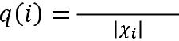

has a local minimum at *i*\* (|.| denotes cardinality), and Î *ς* is a parameter of method, where *ς* is to-tally ordered, that is, reflexive, antisymmetric, and a transitive binary relationship ≤ exists. MSER has been applied to the field of wide baseline stereo matching,33 object tracking in automated surveil-lance systems,36 and automatic 3D reconstruction,37 among other machine learning and computer vision applications. Features in fetal MR images must be tracked for motion detection and correction, and MSER has been shown to be a robust algorithm for tracking and surveillance.36 Hence, MSER could be used to track the feature points in fetal MR images. Such feature points could then be used to compen-sate or detect motion.

**Pseudocode for MSER Algorithm**

**Input:** Image (*I*)

**Output:** Set of regions detected

**SET:** *I*to a low threshold such that the whole im-age appears as a white screen

**SET:** Multiple thresholds are set for I33,38,39

**COMPUTE:** Sort pixel values in decreasing or-der

**COMPUTE:** Using the union-field algorithm,place all of the pixels with intensity *I* in RM

**if** region grows, place that in*Q*(*i*)-memory **else**, place in*Q*(*i*– 1)-memory

**INITIALIZE:** *j*=*i*–

**if** *j*≥ Δ,

go through *Q*-memory;

**if** *Q*(*j*– Δ) ≠ 0,

compute stability *q*(*j*)

**C. SURF**

SURF, a scale- and rotation-invariant interest point detector and descriptor, has proven to be fast, dis-tinctive, and equally repeatable.28 The detector uses an approximation method based on the Hessian matrix (*H*) and has optimal computation time and accuracy. This detector is known as fast-Hessian be-cause it relies on integral images to reduce compu-tation time. The descriptor associates Haar-wavelet responses with the region of interest. The Hessian determinant is used to obtain location and scale in-formation. The Hessian matrix *H* (*x*, *σ*) for a point

* = (*x*, *y*) in an image *I* at scale *σ* is defined as

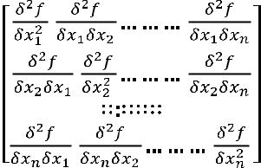

, (2)

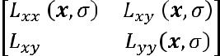

|  |  |  |  |  |
| --- | --- | --- | --- | --- |
|  | , | | (3) |  |
| where |  | , and | simi- |  |
|  |  |

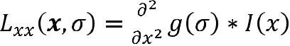

larly, *Lxy* (*x*, *σ*) and *Lyy* (*x*, *σ*). Integral images con-tribute to approximation and fast evaluation of the second-order derivative for box filters, and *Dxx*, *Dxy*, and *Dyy* denote approximations. The Hessiandeterminant relative weights are balanced with

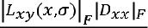 *= K*, where |*x*|*F* is the Frobenius norm.Thisyields 



|  |  |
| --- | --- |
| det(*Happrox* ) = *DxxDyy* − (*K Dxy*)2. | (4) |

*Critical Reviews™ in Biomedical Engineering*

|  |  |
| --- | --- |
| Point-Wise Motion Tracking Algorithms for Fetal MRI | **247** |

A higher pyramid level can be achieved using Gauss-ian-smoothened image pyramids and subsamples. The iterative application of this filter is eliminated through the use of box filters and integral images, which are then computed as

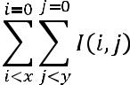

|  |  |
| --- | --- |
| . | (5) |

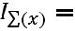

The application of nonmaximum suppression lo-calizes the interest points in the image. Later, the maxima of the Hessian determinant are interpolated in scale and image space. In SURF, descriptor Haar-wavelet responses calculated in *x* and *y* directions are invariant to the rotation. Integral images are used for fast filtering because wavelet sizes are greater at high scales. Six operations are required to compute the response in an *x* or *y* direction. The dominant orientation is estimated by calculating the sum of all responses, and the summed horizontal and vertical responses yield a new vector. The first step in the extraction of the descriptor is the construction of a square region that is centered on the region of inter-est. The region is then further divided into smaller 4 × 4-square subregions. Each subregion consists of regularly spaced sample points. The robustness at the interest point with a Gaussian center increas-es the weight of Haar-wavelet responses *dx* and *dy*. Wavelet responses are summed over each subregion. The sum of the absolute values of responses |*dx*| and |*dy*| is then extracted. Thus, each subregion has the vector *v* as follows:

|  |  |
| --- | --- |
| v = (∑*dx* ,∑*dy* ∑|*dx*| ,∑|*dy*|). | (6) |

Features are compared to determine the same type of contrast using the sign of the Laplacian in the matching stage. This minimal information increas-es performance and allows for faster matching.28 SURF is used for object recognition, image regis-tration, classification, or 3D reconstruction. These features enable SURF to be applied in fetal imaging. Feature extraction in fetal MR images can be used for segmentation, registration, and/or classification. Segmentation of fetal brain, spine, and heart may be leveraged through SURF. The scale- and rotation-invariant interest points of the SURF algorithm can be applied for fetal motion detection and correction.

**Pseudocode for SURF Algorithm**

* Detection of feature points **Input:** Image (*I*)

**Output:** Set of features detected

**COMPUTE:** Integral images of Ifor ***L*** Î {**3,5,7,9,13,17,25,33,49,65**}

**DETERMINE:** Determinant of Hessian usingintegral images and L (algorithm 240)

**end**

**for o = 1:1:4**

**for i = 2:1:3**

*L*=2*oi* + 1

features_detected = features_detected

* KEYPOINTS (*o*, *i*, determinant of Hessian) (al-gorithm 340)

**end**

**end**

**RETURN:** Features detected// SURF descriptor

**Input:** Image (I), set of features detected

**Output:** SURF descriptor, orientation of featuresdetected for pixels x and y for L, and sign of La-placian

**function** SURF_DESCRIPTOR (I, x, y, L)

*θ*=orientation (*I*,*x*,*y*,*L*)40

for i = 1 : 1 : *n* (*n* × *n*) subregion

for *j* = 1 : 1 : *n*

for *u* = –*m* : 1 : *m*

for *v* = –*m* : 1 : *m*

(*x*,*y*) = *S*(*u*,*v*) using

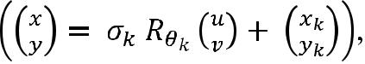

(*x*,*y*) = (*x*,*y*)˥

**COMPUTE:** *dx*(*u*,*v*),*dy*(*u*,*v*) using

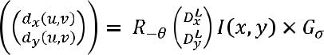

**end**

**Volume 44, Issue 4, 2016**

**248** Geethanath

**end**

**COMPUTE:** *μ*(*i*,*j*) (statistical descrip-

tor40)

**end**

**end**

* = *μk*(*i*, *j*) (concatenate)

SURF (*X*) = Normalized μ ((*l*2 normalization)) **COMPUTE:** Laplacian at scale*L*using

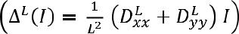

**RETURN:** SURF (X),*θ*, and sign of ∆*L*(*I*)

**End**

**D. Harris Corner Detection Algorithm**

The Harris detection algorithm provides a solu-tion to the edge detection problem by attempting to detect both edges and corners in the image. Harris uses Moravec’s corner detector *E*,29 which is change produced by a shift for image intensities. Four cases must be considered for Moravec’s corner detector:

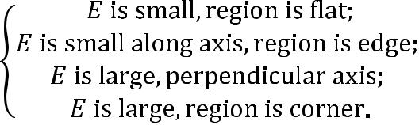

Mathematically, the change *E* produced by a shift (*x*, *y*) for the image intensities *I* is given by

|  |  |
| --- | --- |
| E*x,y* = ∑*u,v* w*u,v*[*Ix*+*u*,*y*+*v* – I*u,v*]2, | (7) |

where *w* represents the image window. A shift of ori-gin is necessary to address all of the possible small shifts about analytic expansion. For small shifts, *E* is written as

E(*x*,*y*) = *Ax*2 + 2*Cxy* + *By*2,

where

*A* = *X*2Ä*w*,

*B* = *Y*2Ä*w*,

and

*C* = (*XY*)Ä*w*.

The noise in the response is eliminated through a smooth circular window. To overcome the problem of operator response to edges, the corner measure must be reformulated. The change *E* for small shift (*x*, *y*) is written as

*E* (*x*,*y*) = (*x*,*y*)*M* (*x*,*y*)*T*,

where *M* is a 2 × 2 symmetric matrix. The eigenval-ues of *M*, represented by *α*, *β*, form a rotationally invariant description of *M* and are proportional to the principle curvatures of the local autocorrelation function, as considered below.

A windowed image of constant intensity is indi-cated when the curvature is small, so that the local autocorrelation function is flat. An edge is indicated when one curvature is high and the other low, so that the local autocorrelation function is ridge shaped. A corner is indicated when both of the curvatures are high, so that the local autocorrelation function is sharply peaked.

Thus, an ideal edge will have large α and zero β, but in reality, *β* is relatively small compared to α. A corner will have large *α* and *β*, and a flat region will have small *α* and *β*.

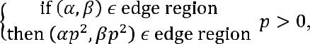

where *p* is a factor of increase in contrast. Corners also have similar conditions. Corner response *R* is considered to select the isolated corner pixels and thin edge pixels. *R* is a function of *α* and *β* alone. The corner response *R* is formulated as

*R* = *Det* − *kTr*2,

where

*Tr* (*M*) = *α* + *β* = *A* + *B*

and

*Det* (*M*) = *αβ* = *AB* − *C*2,

when

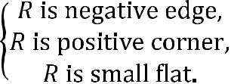

The Harris algorithm is widely used in image match-ing, stitching, mosaicking, and feature tracking.41–44

*Critical Reviews™ in Biomedical Engineering*

|  |  |
| --- | --- |
| Point-Wise Motion Tracking Algorithms for Fetal MRI | **249** |

The algorithm could be used for motion tracking in fetal MRI because it can overcome scale, perspec-tive, and rotation changes.

**Input:** Image (I)

**Output:** Set of corners detected

**for** 0: num_of_pixel

**COMPUTE:** Derivatives*Ix*and*Iy*

**COMPUTE:** Products of derivatives at everypixel, i.e., *Ix2*,*Iy2*,*Ixy*

**COMPUTE:** Sum of the products at each pixel,i.e., *Sx2*, *Sy2*,*Sxy*

**DEFINE:** *M*(*x*,*y*) at each pixel

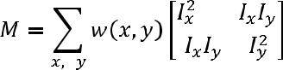

**COMPUTE:** Response of the detector

*R = Det − kTr2*

Threshold the image on the value of *R*

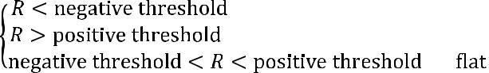

**end**

**E. MinEigen Algorithm**

where *λ* is a predefined threshold.27 Corner detec-tor algorithms find application in the fields of sur-veillance, face recognition, and tracking. MinEigen tracks the features based on the affine image chang-es and is thus suitable for fetal imaging.

**Input:** Image (I)

**Output:** Set of corners detected

**SET:** λ as predefined threshold

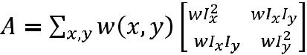

**COMPUTE:** Scalar values*λ1*,*λ2*and eigenvectors*e1*,*e2*

**DETERMINE:** *min*(*λ1*,*λ2*)> λ **III. METHODS**

Three data sets with eight volumes each were considered for this study. Of these 24 volumes of fetal MRI, 16 were then chosen based on a simi-lar anatomy for registration. Subjects scanned had gestational periods of between 23 and 36 weeks, acquired as part of an Ethical Review Board–ap-proved study at the institution. The acquisition was performed with a SSFSE sequence that had param-eters of TR/TE:15000/, 140–180 ms, slice thickness

|  |  |  |
| --- | --- | --- |
| MinEigen is a corner-tracking algorithm that over- | 2.5 mm, and resolution 1.176 × 1.76 mm. The slices |  |
| were selected from different volumes of the same |  |
| comes the aperture problem27 and uses weighted |  |
| subject. The process performed for motion correc- |  |
| autocorrelation for corner detection. The symmetric |  |
| tion is shown in Fig. 1. The selected slices had a |  |
| 2 × 2 matrix *A* of the system must be above the im- |  |
| similar anatomy to enable motion detection in cor- |  |
| age noise level determined by the threshold. Both |  |
| responding volumes. Images were preprocessed |  |
| eigenvalues of *A* must be large for the noise require- |  |
| through unsharp masking and contrast-limited adap- |  |
| ment. Two small eigenvalues produce a roughly |  |
| tive histogram equalization. Blobs and regions were |  |
| constant intensity profile within a window. A large |  |
| considered to be feature points, as described in the |  |
| and small eigenvalue corresponds to a unidirec- |  |
| algorithm section above. Feature vectors/descriptors |  |
| tional texture pattern. Two large eigenvalues can |  |
| represent corners, salt-and-pepper textures, or any | were extracted from the images, as described for |  |
| other pattern that can be tracked reliably. The matrix | each of the above algorithms. Feature vectors from |  |
| *A* is well conditioned when the lesser eigenvalue is | the two selected slices were considered for feature |  |
| sufficiently large enough to meet the noise criterion. | matching, which was performed based on a nearest- |  |
| Given that the two eigenvalues of *A* are *λ1* and *λ2*, a | neighbor ratio. This method eliminates ambiguous |  |
| window is accepted if | matches and uses the matching threshold. Registra- |  |
| min(λ₁,λ₂) > λ, | tion was performed by moving the coordinates of |  |
| detected features of the image to be registered to the |  |

**Volume 44, Issue 4, 2016**

**250** Geethanath

**FIG. 1:** Flow chart of the fetal feature detection for slice-by-slice registration of two slices of similar anatomy for two different volumes of the same subject

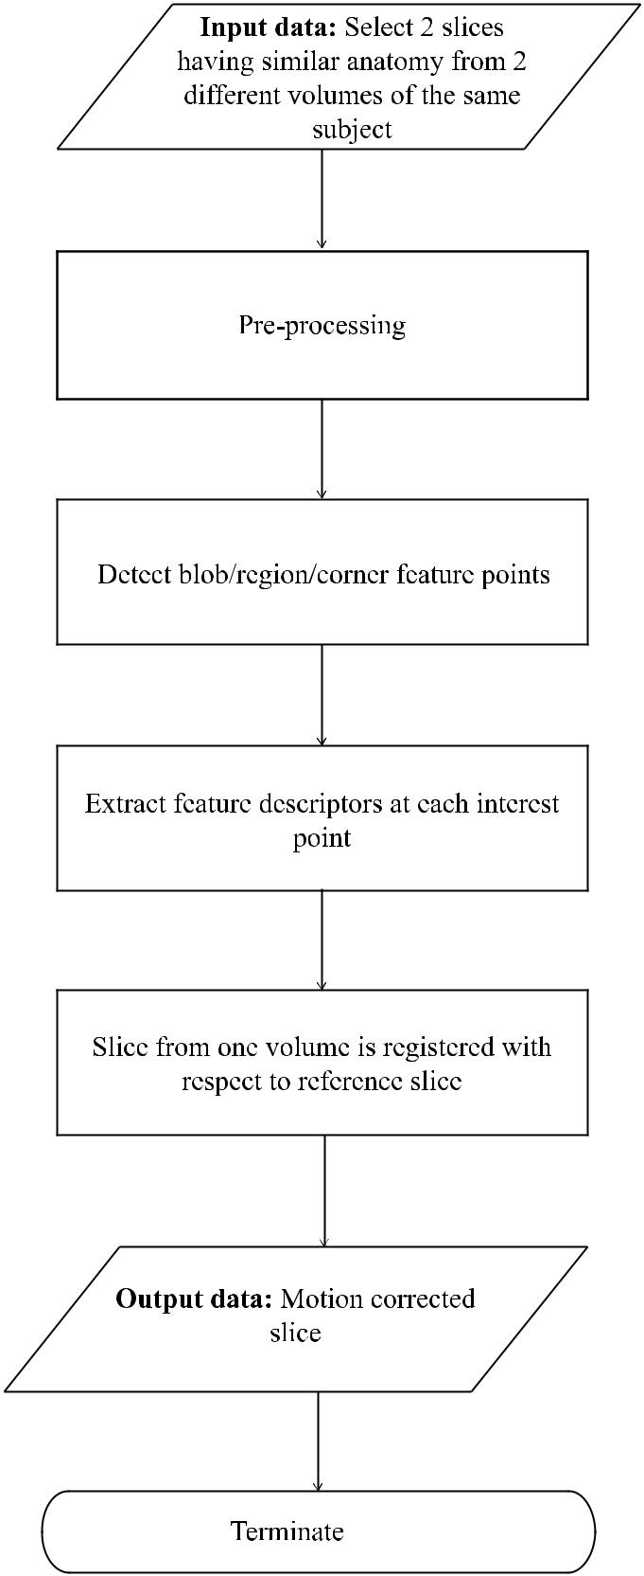

coordinates of corresponding features of the refer-ence image.

**A. *In Silico* Simulations**

Simulations were performed by rotating a given im-age by 45º, after which motion correction algorithms were applied. Images were then matched for slices both with and without rotation. The second image in which the rotation was introduced was registered with respect to the reference image. The algorithms were also applied to the fetal image, acquired where slices with similar anatomy were identified in eight pairs of volumes. These slices were anatomically similar but subject to operations of rotation, scal-ing, and translation. Motion correction algorithm features were found in the reference volume’s slice and a slice from the volume with a similar anatomy. The feature points were mapped between the two slices of the volumes undergoing registration. Fea-ture points were then generated for each slice of the volume. The results were quantified by the root-mean-square error (RMSE) as follows:

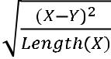

. (9)



**IV. RESULTS**

Figures 2–6 depict the representative performance of each of the five algorithms. The feature points from the first and second input images were detect-ed independently and are shown in Figs. 2a,b–6a,b. The registered images, as shown in Figs. 2c–6c, show noticeable blurring of edges. Yellow lines in the images of Figs. 2d–6d show the tracked feature points in both images. Red circles indicate the de-tected feature points in the first reference image, and the green plus symbols indicate detected feature points of the second image to be registered. The red and cyan in the images of Figs. 2e–6e indicate the differences in images. Where the red and cyan col-ors are prominent, the feature points are reduced in that region. Figure 7 shows that the mean and stan-dard deviation of the RMSE values of all of the eight data sets are similar for the five featured extraction algorithms. The results after slice registration reveal that RMSE measures are similar for the five algo-

*Critical Reviews™ in Biomedical Engineering*

Point-Wise Motion Tracking Algorithms for Fetal MRI

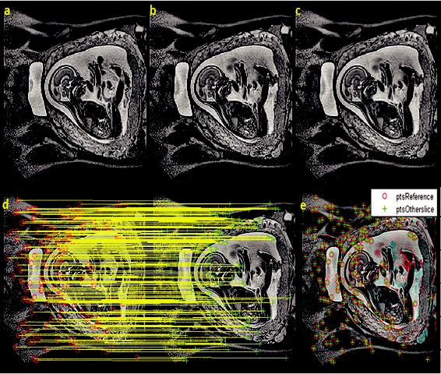

**FIG. 2:** (a) Original input image; (b) second input image(image to be registered with respect to a); (c) output registered image; (d) detected and tracked SURF feature points in images; (e) points on both images

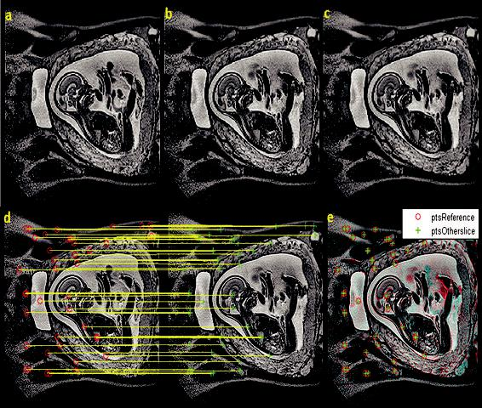

**FIG. 3:** (a) Original input image; (b) image to beregistered with respect to a; (c) registered image; (d) lines depict features tracked using MSER algorithm; (e) points on both images

**251**

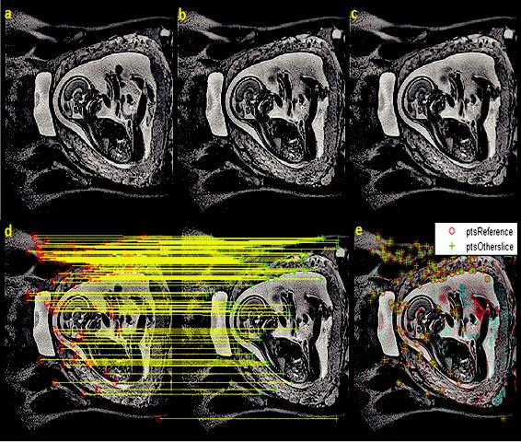

**FIG. 4:** (a) Original input image; (b) image to be registeredwith respect to a; (c) registered image; (d) detected and tracked FAST feature points in images represented by circles and plus symbols, with the matching feature depicted using line; (e) points on both images

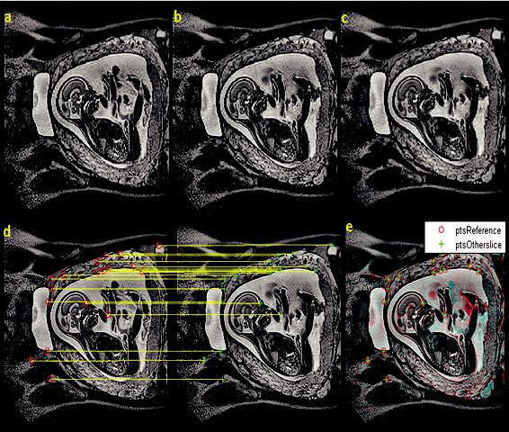

**FIG. 5:** (a) Original input image; (b) second input image(image to be registered with respect to a); (c) registered image; (d) Harris feature points in images, with matched feature points shown; (e) difference between both input images and matching features

rithms discussed. The standard deviation in the case

of SURF is higher compared to the other four al- correspond to the Harris feature detector. It can be

gorithms. Figure 8 shows that the greatest numbers observed that SURF detects the most feature points

of points were extracted from SURF and FAST fea- compared to the other four algorithms within the fe-

ture extraction algorithms. The least feature points tus region. Among the region-based feature detec-

**Volume 44, Issue 4, 2016**

**252** Geethanath

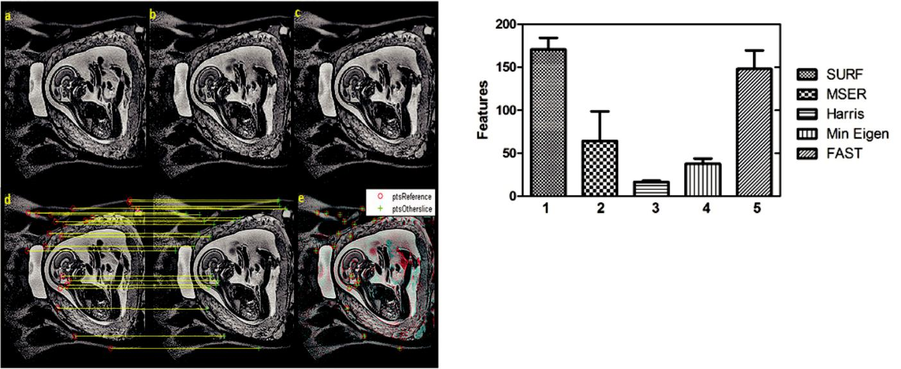

**FIG. 6:** (a) Original input image; (b) image to beregistered with respect to a; (c) registered image; (d) detected and tracked MinEigen feature points in images;

1. difference between both input images and matching features

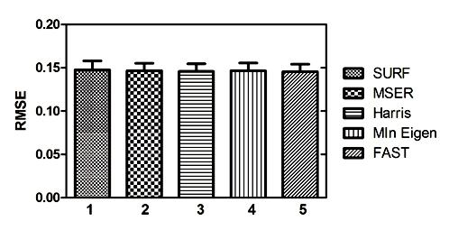

**FIG. 7:** Mean and standard deviation of RMSE valuescalculated before and after registration. (1) SURF; (2) MSER; (3) Harris; (4) MinEigen; (5) FAST

tors, the number of MSER feature points selected were less than that of SURF feature points. The points detected inside the fetus are less in MSER than in SURF. Similarly, among the corner-based feature detectors, it can be observed that FAST has the greatest number of feature points among the cor-ner-based feature detectors. The number of feature points detected is similar those of MinEigen and Harris. The least number of feature points selected occurred in the case of Harris, as depicted in Fig. 4.

**FIG. 8:** Number of feature points selected for motioncorrection. (1) SURF; (2) MSER; (3) Harris; (4) MinEigen; (5) FAST

**V. DISCUSSION AND CONCLUSION**

Fetal motion detection, estimation, and correction in MRI are active areas of research. This work reviews motion estimation algorithms that are readily avail-able with Matlab software (Mathworks Inc., Natick, MA). We have provided detailed descriptions and pseudocodes for each algorithm to enable an im-plementer to proceed on any other platform. The corner-based algorithms of Harris, FAST, and Mi-nEigen and the feature-based algorithms of SURF and MSER are two optimal choices for motion esti-mation and compensation. Edge information of the registered images was blurry due to the process of registration in all of the five cases (as can be ex-pected with registration processes). MSER, Harris, and MinEigen algorithms detect less feature points, as shown in Fig. 7, and all three algorithms result in similar RMSE values, as shown in Fig. 6. The low-est number of feature points was obtained in the case of the Harris algorithm, which had similar registra-tion results to SURF and FAST. Therefore, it can be concluded that Harris is the most computationally efficient of the algorithms evaluated, providing the best motion correction results with minimum fea-ture points. It is important to note that uncorrected fetal motion negatively impacts clinical evaluations with respect to biomarkers, such as those based on structure (volumes of organs, growth estimates, and morphology) and function (fetal cardiac output) as-sessments.45 Therefore, addressing fetal motion in methods related to acquisition, SVR reconstruction,

*Critical Reviews™ in Biomedical Engineering*

Point-Wise Motion Tracking Algorithms for Fetal MRI

and postprocessing, such as those described above, is a critical component of fetal MR examinations.

**REFERENCES**

1. Saleem SN. Fetal MRI: An approach to practice: A re-view. J Adv Res. 2014 Sept 30;5(5):507–23.
2. Rao R, Venkatesan R, Geethanath S. Role of MRI in med-ical diagnostics. Resonance. 2015 Nov 1;20(11):1003–11.
3. Hershey DW. Fetal imaging: Executive summary of a joint Eunice Kennedy Shriver National Institute of Child Health and Human Development, Society for Maternal-Fetal Med-icine, American Institute of Ultrasound in Medicine, Amer-ican College of Obstetricians and Gynecologists, American College of Radiology, Society for Pediatric Radiology, and Society of Radiologists in ultrasound fetal imaging work-shop. Obstet Gyn. 2014 Oct 1;124(4):836.
4. Malamateniou C, Malik SJ, Counsell SJ, Allsop JM, Mc-Guinness AK, Hayat T, Broadhouse K, Nunes RG, Eder-ies AM, Hajnal JV, Rutherford MA. Motion-compensa-tion techniques in neonatal and fetal MR imaging. Am J Neuroradiol. 2013 Jun 1;34(6):1124–36.
5. Edwards AD, Arthurs OJ. Paediatric MRI under sedation: Is it necessary? What is the evidence for the alternatives? Ped Radiol. 2011 Nov 1;41(11):1353.
6. Bonel H, Frei KA, Raio L, Meyer-Wittkopf M, Remonda L, Wiest R. Prospective navigator-echo-based real-time triggering of fetal head movement for the reduction of ar-tifacts. Eur Radiol. 2008 Apr 1;18(4):822.
7. Vertinsky AT, Rubesova E, Krasnokutsky MV, Bammer S, Rosenberg J, White A, Barnes PD, Bammer R. Per-formance of PROPELLER relative to standard FSE T2-weighted imaging in pediatric brain MRI. Ped Radiol. 2009 Oct 1;39(10):1038–47.
8. Forbes KP, Pipe JG, Karis JP, Farthing V, Heiserman JE. Brain imaging in the unsedated pediatric patient: Compar-ison of periodically rotated overlapping parallel lines with enhanced reconstruction and single-shot fast spin-echo sequences. Am J Neuroradiol. 2003 May 1;24(5):794–8.
9. Zaitsev M, Dold C, Sakas G, Hennig J, Speck O. Mag-netic resonance imaging of freely moving objects: Pro-spective real-time motion correction using an external optical motion tracking system. Neuroimage. 2006 Jul 1;31(3):1038–50.
10. Hayat TT, Nihat A, Martinez-Biarge M, McGuinness A, Allsop JM, Hajnal JV, Rutherford MA. Optimization and initial experience of a multisection balanced steady-state free precession cine sequence for the assessment of fetal behavior in utero. Am J Neuroradiol. 2011 Feb 1;32(2):331–8.
11. Chen Q, Levine D. Fast fetal magnetic resonance imaging techniques. Topics Magn Res Imag. 2001 Feb 1;12(1):67–79.

**253**

1. Lustig M, Donoho D, Pauly JM. Sparse MRI: The ap-plication of compressed sensing for rapid MR imaging. Magn Res Med. 2007 Dec 1;58(6):1182–95.
2. Geethanath S, Reddy R, Konar AS, Imam S, Sundaresan R, Venkatesan R. Compressed sensing MRI: A review. Crit Rev Biomed Eng. 2013;41(3):184–204.
3. Pang Y, Zhang X. Interpolated compressed sensing for 2D multiple slice fast MR imaging. PloS ONE. 2013 Feb 8;8(2):e56098.
4. Pang Y, Jiang J, Zhang X. Ultrafast fetal MR imaging us-ing interpolated compressed sensing. Proc Intl Soc Mag Res Med. 2014 May 10–16;2224.
5. Rousseau F, Glenn O, Iordanova B, Rodriguez-Carranza C, Vigneron D, Barkovich J, Studholme C. A novel approach to high resolution fetal brain MR imaging. Med Image Comput Comput Assist Interven. 2005; 548–55;3749.
6. Gholipour A, Estroff JA, Barnewolt CE, Connolly SA, Warfield SK. Fetal brain volumetry through MRI volu-metric reconstruction and segmentation. Int J Comput As-sist Radiol Surg. 2011 May 1;6(3):329–39.
7. Keraudren K, Kuklisova-Murgasova M, Kyriakopoulou V, Malamateniou C, Rutherford MA, Kainz B, Hajnal JV, Rueckert D. Automated fetal brain segmentation from 2D MRI slices for motion correction. Neuroimage. 2014 Nov 1;101:633–43.
8. Gholipour A, Estroff JA, Warfield SK. Robust super-reso-lution volume reconstruction from slice acquisitions: Ap-plication to fetal brain MRI. IEEE Trans Med Imag. 2010 Oct;29(10):1739–58.
9. Jiang S, Xue H, Glover A, Rutherford M, Rueckert D, Hajnal JV. MRI of moving subjects using multislice snap-shot images with volume reconstruction (SVR): Applica-tion to fetal, neonatal, and adult brain studies. IEEE Trans Med Imag. 2007 Jul;26(7):967–80.
10. Rousseau F, Glenn OA, Iordanova B, Rodriguez-Carranza C, Vigneron DB, Barkovich JA, Studholme C. Registra-tion-based approach for reconstruction of high-resolution in utero fetal MR brain images. Acad Radiol. 2006 Sep 30;13(9):1072–81.
11. Kim K, Habas PA, Rousseau F, Glenn OA, Barkovich AJ, Studholme C. Intersection based motion correction of multislice MRI for 3-D in utero fetal brain image forma-tion. IEEE Trans Med Imag. 2010 Jan;29(1):146–58.
12. Kuklisova-Murgasova M, Quaghebeur G, Rutherford MA, Hajnal JV, Schnabel JA. Reconstruction of fetal brain MRI with intensity matching and complete outlier removal. Med Image Analysis. 2012 Dec 31;16(8):1550–64.
13. Kainz B, Steinberger M, Wein W, Kuklisova-Murgasova M, Malamateniou C, Keraudren K, Torsney-Weir T, Ruth-erford M, Aljabar P, Hajnal JV, Rueckert D. Fast volume reconstruction from motion corrupted stacks of 2D slices. IEEE Trans Med Imag. 2015 Sep;34(9):1901–13.

**Volume 44, Issue 4, 2016**

**254**

1. Rosten E, Drummond T. Fusing points and lines for high performance tracking. Proceedings of the 10th IEEE In-ternational Conference on Computer Vision; 2005 Oct 17; Beijing China. Institute of Electrical and Electronics En-gineers; 2005. p. 1508–15.
2. Shi J, Tomasi C. Good features to track. Proceedings of IEEE Computer Society Conference on Computer Vision and Pattern Recognition; 1994 Jun 21; Seattle, WA, USA. Institute of Electrical and Electronics Engineers; 1994.
   1. 593–600.
3. Matas J, Chum O, Urban M, Pajdla T. Robust wide-base-line stereo from maximally stable extremal regions. Im-age Vision Comput. 2004 Sep 1;22(10):761–7.
4. Bay H, Tuytelaars T, Van Gool L. SURF: Speeded up robust features. Comput Vision Image Understand. 2006;110(3):404–17:3951.
5. Harris C, Stephens M. A combined corner and edge de-tector. Proceedings of the 4th Alvey Vision Conference; The plessey Company plc. 1988 Aug 31; London, UK.
   1. 145–51.
6. Rosten E, Porter R, Drummond T. Faster and better: A ma-chine learning approach to corner detection. IEEE Trans Pattern Analysis Machine Intel. 2010 Jan;32(1):105–19.
7. Yu TH, Kim TK, Cipolla R. Real-time action and recog-nition by spatiotemporal semantic and structural forest. British Machine Vision Conference; 2010 Aug 31–Sep 3; Cambridge, UK. p. 6.
8. Koelstra S, Patras I. The FAST-3D spatio-temporal inter-est region detector. Proceedings of the 10th Workshop on Image Analysis for Multimedia Interactive Services; 2009 May 6; London, UK. Institute of Electrical and Electron-ics Engineers; 2009. p. 242–5.
9. Matas J, Chum O, Urban M, Pajdla T. Robust wide-base-line stereo from maximally stable extremal regions. Im-age Vision Comput. 2004 Sep 1;22(10):761–7.
10. Sedgewick R. Algorithms. Reading, MA: Addison-Wes-ley Professional; 1988.
11. Kristensen F, MacLean WJ. Real-time extraction of maxi-mally stable extremal regions on an FPGA. Proceedings of the IEEE International Symposium on Circuits and

Geethanath

Systems; 2007 May 27; New Orleans, LA. Institute of Electrical and Electronics Engineers; 2007. p. 165–8.

1. Kristensen F, Hedberg H, Jiang H, Nilsson P, Öwall V. Hardware aspects of a real-time surveillance system. Sixth IEEE International Workshop on Visual Surveil-lance; 2006 May 13; Graz, Austria. Institute of Electrical and Electronics Engineers; 2006. p. 161–8.
2. Martinec D, Pajdla T. Consistent multi-view reconstruc-tion from epipolar geometries with outliers. Image Analy-sis. 2003;477–86:2749.
3. Donoser M, Bischof H. Efficient maximally stable ex-tremal region (MSER) tracking. IEEE Computer Society Conference on Computer Vision and Pattern Recognition; 2006 Jun 17–22; New York, NY. Institute of Electrical and Electronics Engineers; 2006. p. 553–60.
4. Forssén PE. Maximally stable colour regions for recogni-tion and matching. IEEE Conference on Computer Vision and Pattern Recognition; 2007 Jun 17–22; Minneapolis, MN, USA. Institute of Electrical and Electronics Engi-neers; 2007. p. 1–8.
5. Oyallon E, Rabin J. An analysis of the SURF method. Im-age Proc Online. 2015 Jul 20;5:176–218.
6. Mistry S, Patel A. Image stitching using Harris feature detection. Int Res J Eng Tech. 2016 Apr;03(04):2220–6.
7. Chandratre R, Chakkarwar V. Image stitching using Har-ris feature detection and random sampling. Int J Comput App. 2014 Mar;89(15):14–9.
8. Chen J, Zou LH, Zhang J, Dou L. The comparison and application of corner detection algorithms. J Multimed. 2009 Dec 1;4(6):435–41.
9. Han Y, Chen P, Meng T. Harris corner detection algorithm at sub-pixel level and its application. Proceedings of the 37th International Conference on Software Engineering; Atlantis Press. Paris, France. 2015 May 16–24; Florence, Italy. p. 133–7.
10. Seed M, van Amerom JF, Yoo SJ, Al Nafisi B, Grosse-Wort-mann L, Jaeggi E, Jansz MS, Macgowan CK. Feasibility of quantification of the distribution of blood flow in the nor-mal human fetal circulation using CMR: A cross-sectional study. J Cardiovasc Mag Res. 2012 Nov 26;14(1):79.

*Critical Reviews™ in Biomedical Engineering*